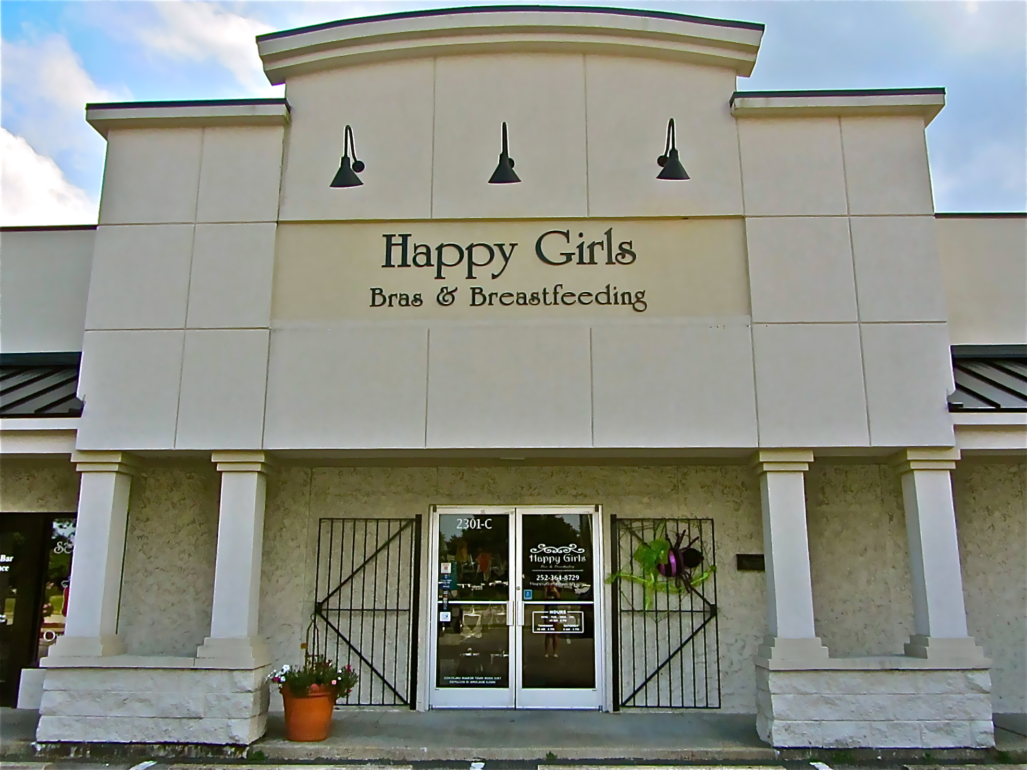

East Carolina University Small Business Institute®
Dr. Michael L. Harris, Director
Jared Taunton, Associate Director
(252) 737-1057
harrismi@ecu.edu

2301-C Stantonsburg Rd.,
Greenville NC 27834
Phone: (252) 364-8729
Email: sophie@happygirlsbandb.com

[Consuelo Beasinger] [Shannon Breedlove] [Ayren Burns] [Kelsey Edmisten] [Aaron Hall]

Letter of Engagement:
Happy Girls - Bras and Breastfeeding
ECU Small Business Institute ®

Background
Happy Girls - Bras and Breastfeeding is a new company that specializes in maternity and nursing bras.The store started with the will of a retired nurse and lactation specialist who wanted to help nursing mothers. The business will soon grow from personally fitting maternity and nursing bras to a two-fold business that also offers lactitation consultations. The desire to inform mothers and the community about breastfeeding has driven the company.
This company started from an idea, drive, passion, and the need to educate, which are the ingredients this company used as the foundation to start Happy Girls. They created a can-do and positive attitude that can be felt when you walk in the doors of the store.

Approach
After a visit with the founder and owners of Happy Girls, it was made clear that the company needed a foundation established in the finance and marking areas, and an approach to start lactation consultations for the customers/clients. The mission of this business would be to get the word out about the new services available by establishing a firm marketing strategy. Seeking out the women that are having babies would be the first focus.
Currently, the main marketing efforts are geared towards Facebook and two ads in a magazine. A strategy would include insuring that a company website is available. A company website is the first impression made to the customers and primary point of contact.
From the POS system “LightSpeed” that is already in place, a customer database needs to be implemented. The information collected from customers will allow for mail ads to be distributed or calendar store events to be communicated. To find our establish new clients, advertising and promotions will be used by ad placements or mailings for comapny awareness.

Deliverables
Recommendations have already begun within the second meeting, which were taken and implemented on-the-spot. Our consulting team will continue to make recommendations as well as insure on-the-spot corrections or suggestions for the company. With resources, research, and meeting collaborations, our team will give the company the competitive edge that is needed to be successful. All information researched and obtained by our tieam will be provided to the company along with a presentation to clearly communicate the written report, at the end of this project.

Project Schedule
Research is to be completed by September 24, 2012

Problem Identification is to be completed by October 1, 2012

1st version of Recommendations is to be completed by October 1, 2012

Final version of Recommendations is to be completed by November 12, 2012

Final Consulting Document is to be completed and presented by December 6, 2012

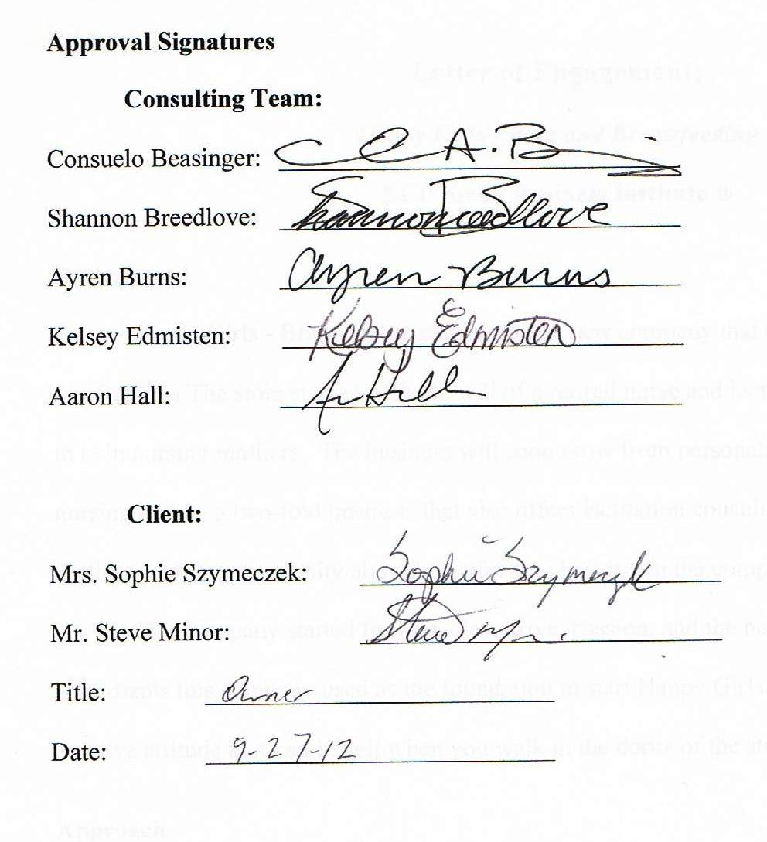

SUMMARY REPORT
HAPPY GIRLS BRA & BREASTFEEDING
GREENVILLE, NC 27858

Happy Girls is a small specialty store owned and managed by Sophie Szymeczek. The business is located on 2301-C Stantonsburg Road in Greenville, North Carolina.

PROBLEMS IDENTIFIED:

1. Marketing
So far, the marketing for Happy Girls has had some success, while costing valuable resources. With a better marketing plan that is tied to a Point-of-Sale system, the marketing can be more efficient and more targeted. A detailed marketing plan includes the target market, product mix, pricing, placement, and promotion.

2. Management Information Systems
Happy Girls needs to improve the MIS operations of the business. Improving the MIS would give the store the ability to better track inventory, monitor trends, and grasp a better understanding of the store a different times of the year.

RECOMMENDATIONS:

1. POINT-OF-SALE SYSTEM
Mastering the LightSpeed point-of-sale system will improve the overall operations of the business. It will make the store look more professional as well as make transactions with customers easier. This will be done by purchasing the barcode scanning accessories that are compatible with LightSpeed.

2. INVENTORY SYSTEM
Managing inventory more efficiently will improve the knowledge and decision making abilities of the business. Mastering the LightSpeed inventory tracking software that is currently used can help handle inventory and sales. The software will also help with checking products in and out of the store. It is also efficient to do a hard count of all inventory once a year. Once mastered, everything will run more efficiently.

3. COLLECTING CUSTOMER INFORMATION
Collecting customer information using customer surveys and the point of sale system will be an important step in future promotions. The survey which is presented at check-out will have fields for important personal info. The information can then me put into the POS system and used for making promotions more targeted.

4. FINANCIAL EFFICIENCY
Mastering QuickBooks will help the store owners understand the financial state of the business and make keeping track of finances for efficient. The software has the ability to provide owners with detailed reports that show trends and enable owners to make decisions that will increase profits.

5. COMPREHENSIVE MARKETING PLAN
A complete marketing plan has been created that puts an emphasis on a target market, product mix, pricing strategies, placement, and promotions. The plan will coordinate with the POS system information to make sure every dollar spent on promotions is maximized. These five marketing strategies will enhance different areas of the store that are important to the success of any business.

In conclusion, our team would like to thank Sophie Szymeczek for her assistance in putting together this consulting document. It is our hope that these recommendations will enhance the overall operations of Happy Girls today and in the future.

SIGNATURE ____________________

COMPANY _____________________

DATE __________________________

TABLE OF CONTENTS
SUMMARY REPORT
HISTORY………………………………………………………………………………………....#
FIRM ANALYSIS……………………………………………………………………..….#
INDUSTRY ANALYSIS……………………………………………………………...….#
S.W.O.T. ANALYSIS………………………………………………………………….…#
STATEMENT OF OWNER’S OBJECTIVES…………………………………………………....#
IDENTIFIED PROBLEMS……………………………………………………………………….#
RECOMMENDATIONS………………………………………………………………………….#
MARKETING……………………………………………………………………………..#
MIS……..………………………………………………………………………………....#

CONCLUSION……………………………………………………………………………………#
REFERENCES……………………………………………………………………………………#
APPENDIX
HISTORY
Brief History of the Business
Happy Girls is owned and operated by Mrs. Sophie Szymeczek. The business is a bra and breastfeeding accessories store that targets new and expecting mothers. It offers specialty products that cannot be found in typical clothing stores. The store also provides consulting services, information sessions for nursing mothers, and a comfortable environment for mothers to nurse their child.
Happy Girls is located at 2301-C Stantonsburg Road in Greenville, NC. The location of the store is across from the Vidant Health Center in a small shopping center between a clothing store and a steakhouse. Mrs. Szymeczek chose to rent the space not only because it was the best available, but because it was the perfect size for what she needed.
Upon retiring from Vidant Health as a lactation consultant for 30 years, Mrs. Szymeczek was curious to find out how many specialty bra stores were in the Greenville area. After searching online, she discovered that the closest stores were as far away as Raleigh and Wilmington. She discovered that there was potential in opening a specialty store in Greenville. By March of 2012, she and her business partner, Steve Minor, had developed a business plan. The partners then put their time, money, and effort together to create the store and opened for business on June 18, 2012.
Firm Analysis
Happy Girls carries a wide variety of specialty products. The store offers products to new and expecting mothers including regular bras, nursing bras, tank tops, pads and pillows, maternity supports, and breast pumps. The store’s main suppliers are Panache, Le Mystere, Amamante, Undercover Mama, Bamboobies, The Little Bra Co., Medela, Bravado, and Simple Wishes. They also sell baby toys, locally hand-knitted accessories, and various lotions and vitamins.
Through visits to the store, it is apparent that the daily operations are relaxed. Mrs. Szymeczek is responsible for placing orders with suppliers, organizing shipment plans, cleaning the bathrooms, fitting customers, and paying the bills. Her partner manages the inventory and financial aspects. Other than the owners, there are no employees other than her daughter who comes in when needed. They do not receive a salary; instead they rely on wages from outside ventures. The business hours for the store vary throughout the week. On Mondays, Tuesdays, Wednesdays, and Fridays the operating hours are from 10am-6pm. Thursday’s hours are from 10am-8pm, Saturday’s hours are from 9am-3pm, and on Sunday the store is closed.
Before opening, Mrs. Szymeczek was advised by a friend to use Apple products to run the business. It is the only POS program that is compatible on Apple’s Mac operating system and handles all the finances, inventory, and operating transactions. It is also compatible with Quick Books and can be accessed on an iPad while handling all credit card transactions.
Marketing
Happy Girls uses a variety of marketing tactics including magazines, Internet, Facebook, and newspapers. The website was created by a friend and offers information on the store along with general breastfeeding information. Also included are discounts and promotional offers, a calendar of events, and links to local and regional events. They have their own Facebook page with almost 730 “likes” where mothers regularly post questions about the store and breastfeeding. Because the demographic for mothers includes high usage of social media for information and shopping, the Facebook page is regularly updated and offers promotions. There is also discussion about purchasing advertisements on Facebook in the future.
“Her” magazine comes out with an issue every month which costs $300 for each issue. Happy Girls was featured in the Work Week section of the Daily Reflector on July 16, 2012 (Figure 1). The insert highlights businesses in Greenville and introduces new ones in the form of an article. Buying an advertisement in “Work Week” magazine costs another $300. Happy Girls pays $300 a month to advertise on the WNCT website, where they have an average of 41 hits a week.
Figure 1: Photo featured in Work Week article
The typical customers of Happy Girls are breastfeeding moms and large breasted women. They also market to women of all breast sizes. Their customers come from all over eastern North Carolina, including Greenville, New Bern, and even Raleigh. To track customers, Happy Girls has the use of LightSpeed that holds a customer memory within its database.
Happy Girls does not always track their marketing efforts, other than through the Internet. The best way for them to track the effects of their advertising is the amount of “Likes” on Facebook, which is up to 727 Likes. Another way Happy Girls can track their efforts is the number of clicks they get on WNCT’s website where they average 41 clicks a week.
In the future Happy Girls plans on participating in local health fairs including the annual Maternity Fair, Chamber of Commerce activities, and events showcasing businesses or services in Greenville. Most of the events reach a large potential customer base. The Maternity Fair in Greenville alone has about 1,000 participants each year.

Products
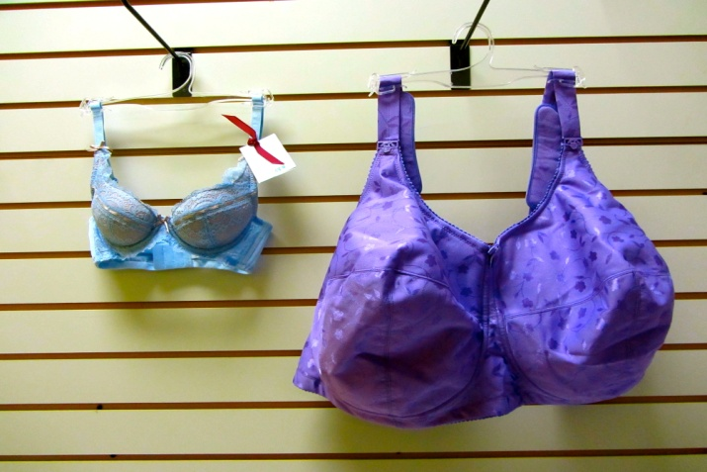
Happy Girls sells a large variety of stylish and quality bras. They offer bras by Panache and Le Mystere in band sizes 28-44, and cup sizes D-J (Figure 2). Recently, inventory has expanded to include cup sizes A through N. Nursing Bras, also by Panache, LeMystere, and Bravado are available as well as nursing tank tops by Undercover Mama and Bravado.
Figure 2: Bras sized 28-A (left) and 44-I (right)
In addition to bras, a wide selection of maternity equipment and support to new mothers and their families are available. Bamboobies nursing pads and soothing pillows, pumping bras by Simple Wishes, and Fenugreek capsules and Gentian Violet are examples of the products on the shelves. Many Medela products are sold such as maternity supports, Symphony breast pump rentals, and breast pumps and parts (also by Ameda). The store also serves as a comfortable location for mothers to stop in and nurse or pump at any time.
Prices for products are marked at retail prices for electric double personal use breast pumps ranging from $170-$400, and hospital grade rental breast pumps at $15 per week. Bras are priced according to manufacturer recommendations, ranging from $35-$90 each. Gift certificates are also available.

Store Layout
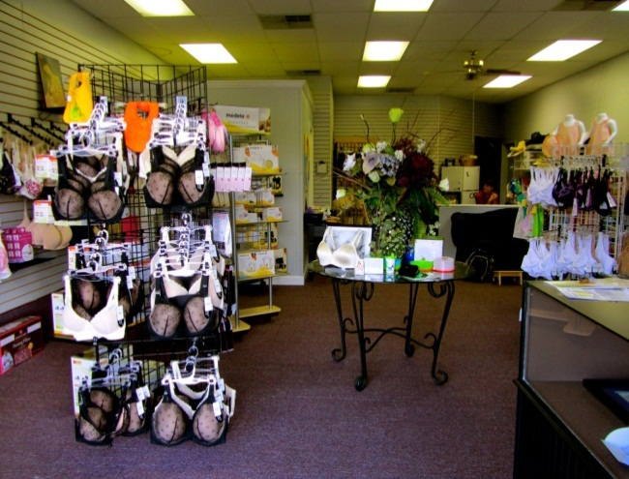
Upon entering the store (Figure 3), there is a glass display table in the center of the floor with a few sample products displayed in front of a display of flowers. To the left there are maternity/breastfeeding bras displayed in racks on the wall with different breastfeeding equipment on four sided racks in front. To the right, the front counter is adjacent to the wall and door. Regular bras in a wide variety of sizes hang on the right-hand wall. There is a small relaxation corner which also serves as a play area for children and has a couch, children’s toys and books, and a circular child’s clothing rack. The couch backs up to the half wall that separates—but does not close off—the office area from the store floor. In the back left corner is the restroom that is diaper changing accessible, and adjacent to the bathroom is the store’s one changing room.
Figure 3: The store layout
Finances
According to financial records and bank statements, the owners invested a total of $33,723.31 into the business and did not take out any loans. Before the store opened, $9,282.38 was spent on startup costs and renovations to the building. During the opening month of June, $16,293.23 of merchandise was purchased and approximately $2,500 was spent on further startup costs and maintenance. The first rent payments of $1,150 were paid in this month and the first marketing expenses of $810 were recorded in June. From the store’s grand opening on June 18 to the end of the month, the store had total revenue of $3,761.84.
The following two full months of operation, July and August, showed revenues of $10,503.79 and $9,897.15 respectively. Expenses totaled $13,356.01 in July and $11,062.30 in August. Around 77% of the expenses in July and 61% of expenses in August were merchandise purchases. Other major expenses during these months were the rent payments and startup costs associated with the purchase of the inventory and POS software. At the end of August, the total cash position of Happy Girls was $2,566.86.
Around the time the business plan was created, cash projections over the first three years were developed by a local accountant. Apart from that visit, there has been no additional contact between the business owners and any accountants. The only way revenues and expenses are tracked is through basic online bank statements. In order to create an income statement, an employee would have to skim over the statement to see exactly where money was spent and enter those figures into a spreadsheet.

Industry Analysis
The origin of the name for “bra” is “brassiere.” In regards to nursing bras, it is recommended that the buyer should wait until the last possible minute to purchase a maternity bra because a woman’s breasts change once they have a baby and begin actually feeding. When a nursing mother goes to find a breastfeeding bra, she should buy at least three because they will be washed often. These bras will be worn up to one year.
The market for breastfeeding bras or maternity bras is not new. If an entrepreneur wants to apply their focus on breastfeeding bras then they are narrowing the market. There are many bras out there but to focus on just one type will establish a competitive advantage. The Standard Industrial Classification (SIC) Code for the industry is 2342 Maternity Bras and Corsets.
In the industry of maternity and nursing bras, it goes hand-in-hand for a company to also offer services of breastfeeding consultations, also known as lactation consultations. The Standard Industrial Classification (SIC) Code for this service industry is 729 Miscellaneous Personal Services. Breastfeeding is a natural source of nutrients for the infants. The American Academy of Pediatrics recommends that mothers breastfeed for at least the first twelve months of life. The World Health Organization promotes breastfeeding for two years. The International Board Certified Lactation Consultant (IBCLC) certifies practitioners to teach a new mother a skill that has to be learned by both mother and child. There is a service charge for the consultations, which some insurance companies may pay for with a referral from their physician.
The recession of the new millennium has affected everyone, and specialty retail stores are no exception. Consumers are paying more attention to how they spend their money by buying necessities and fewer luxuries. If a person needs a specialty item, they expect to get high value, and both businesses and consumers are pressured to cut costs wherever they can. There is a need for businesses to have greater control over their supply chain and inventory, and also need to apply their attention to advertising and promotions. The target market for this type of specialty store includes teens and women. Personal service needs to be superior in today’s market, because customers want to feel appreciated by the businesses at which they shop.
National Trends
With chain store consumer gadget claims revenues down, it seems shoppers are heading online or to specialty stores to get their goods. Every store, big and small, has felt the crunch of the economy. More consumers now shop online for the gadgets they need because they are generally well-educated about what they want; it follows that manufacturers are transforming into retail vendors. However, stores like Best Buy and Walmart® have not scared all the mom-and-pop stores away; more specialty retail stores are opening, but are too small to make a difference in the market. Customers still need that personal one-on-one experience, but they do not want to hassle with chain stores just for one or two necessary items.
Larger stores generally do not provide personal fitting, consultations, and personal customer service—all very valuable market niches. Locally owned specialty stores also boast stronger community connections; corporate stores may donate some to charities, but a local store owner is better able to develop relationships within their communities. “Price is not the most important reason for customer loyalty”, says Jack rice, a consultant in Longmont, CO. Surveys prove that customers often return for reasons other than saving money, such as inventory availability, prompt service, and value image.
Industry Leaders
When one searches for “breastfeeding accessories,” the first website that comes up is Motherhood.com. They have a great retail website where customers can get a large variety of products. However, the closest brick-and-mortar store is over 50 miles away from Greenville. They carry popular clothing brand names, including Jessica Simpson and Heidi Klum, as well as a variety of apparel (swim, active, etc.). However, their selection of breastfeeding accessories is sparse. This is mostly a website for maternity clothes.
The second item on the search list is Babies-R-Us, and they carry a much wider variety of breastfeeding accessories—including the brand Medela, which Happy Girls carries. They also sell baby clothes, furniture, toys, and accessories, and they have an easy-to-navigate site and local store in Greenville.
A search for “nursing bras” again puts Motherhood.com at the top, followed by Bravado and Leading Lady. Several other retail sites follow, but none of them have a comparable selection. Bravado has an informative, easy-to-use website dedicated solely to nursing bras, but their in-person retail selection is restricted to stores that order inventory from them. Leading Lady has a similar situation, with a wider variety of styles, but with an equally small selection for women ranging into the H-K sizes. Both brands deal solely through vendors.
The most popular “regular-bra” vendor would be Victoria’s Secret, due to heavy advertising and retail availability. Their prices range higher than those of other clothing retailers such as Wal-Mart and Target, but they’re known for their beautiful styles and quality of products. They have gorgeous stores with feminine color schemes and easily-navigated drawers of product, and almost every bra style is on display. The downfall of Victoria’s Secret is that they cater only to the most common bra sizes, forcing well-endowed women to purchase merchandise that is often not a proper fit.
A small specialty store like Happy Girls can compete with these industry leaders by good marketing practices and word of mouth. Becoming more well-known is the best way to compete, because if no one knows the store exists, nobody is going to shop there. Also, having a high repeat-customer clientele is crucial to any small business. Repeat customers are more likely to recommend a small store with strong customer service to their friends, family, and acquaintances. Having an excellent level of service and making a connection with every person who walks in is a great way to develop customer loyalty.
Future Trends
Gone are the days when going without a bra was the most convenient way to breastfeed due to the sagging of breasts and complaints of discomfort. There are more than four million babies born annually, causing more people to take notice of the maternity clothing market. If every expectant mother purchased five new maternity garments in one year, that would be an average of 20 million maternity garments sold in the United States alone. The maternity clothing market is causing a greater buzz than ever before as people notice the demand and lack of supply, putting profit margins up to 100%. More people are starting to design, manufacture, and sell maternity products or purchase maternity clothing at wholesale and reselling for a profit. One company that has flourished is Bravado Designs, which came out with the first leopard print nursing bra, now considered to be the “Original Bravado Nursing Bra.”
In the future, the maternity industry will continue to provide information, support, and variety of products that will suit breastfeeding needs. Every woman has specific issues and needs while breastfeeding, and as the maternity industry grows, more variety will be available to expecting mothers such as fabric, elasticity, and padding, access to the nipple, sizes, and fashionable design. Molded cup nursing bras are the fastest growing product because they give the woman a fresh, young look while keeping them confident and comfortable. There is an increase in active wear in the maternity industry due to new research that indicates it is beneficial for expecting mothers to exercise during and after pregnancy. Cotton/Lycra has increased as the choice fabric for nursing bras; cotton gives the bra breathability and Lycra’s body sculpting properties offer youthful, natural looking support, forgiving fit and easy-care properties.
The manufacturers of the maternity industry are paying more attention to what their customers want and need. Maternity clothing manufacturers establish their differentiation largely through style and quality, and are saying that style and quality are the big players when expecting mothers are deciding which product to choose. Manufacturers of maternity wear make all the difference in women’s comfort and wallets, either causing the women to have to replace a maternity bra or camisole or having the originals last throughout the entire maternity period. The major maternity wear manufacturers say that creating maternity clothing involves more than just letting out regular women’s fashion at the belly seams. This practice is not the best for pregnant women because more fabric simply covers up a women’s ever-growing belly, causing her to look even larger. The manufacturers have done research and studied pregnant women’s needs and desires and tailor the clothing specifically for them. Manufacturers want to accentuate new mothers’ curves and bring out the best assets to their new bodies.
There has been a lot of talk about breastfeeding with the Time Magazine article and cover entitled “Are You Mom Enough?” that came out May 2012. The article talks about the debate over breastfeeding and attachment parenting. With this issue, great controversy and attention has been brought to the maternity industry. People are saying that the maternity industry is showing great growth and prosperity, that it has recently attracted much interest in the business world, and will continue to grow as more and more innovations are discovered to make pregnancy and breastfeeding more comfortable.
Greenproofing and greenbirth are sweeping through the maternity circles. People (typically women) are able to become consultants for pregnant women who want to go green. In 2010 the International Maternity Institute launched the industry’s first greenproofing and greenbirth certification programs. These classes are to train and prepare maternity and birth professionals with the knowledge and practical experience to prepare pre-conceiving, expecting, and new parents for toxic free living. Just as babyproofing is designed to prevent babies from harming themselves or causing damage around the home, a certified greenproofer is a maternity eco-consultant who provides education, support, resources to protect the baby and family from toxic substances that may pose a potential threat to health. Greenproofing covers preconception, pregnancy and birth, labor, postpartum and newborn care, skin and body care, food and nutrition, product awareness, nursery design and safety, and playroom safety and childcare.
The online maternity industry generates about $70 million annually. Consumers are turning to online shopping for their maternity products instead of traveling to a physical store. The number of maternity wear websites is constantly increasing and drawing in customers. As the cultivating presence of e-commerce over the past decade, online-only stores have grown in popularity producing a major threat to the physical establishments. During the recession when price comparisons were a necessity, e-tailors offered unmatched savings. Online shopping will continue to reign, thus threatening brick-and-mortar maternity wear retailers. However, the negative factor of the online sector of the maternity industry is the personalization aspect. Many women need to be personally sized to get the right bra with the right fit that will do the best job.
Many women, after giving birth and raising their children, have decided to open a maternity store. One key factor that successful maternity shops provide is not only maternity clothing but helpful services such as consulting. Pickles and Ice Cream Maternity Apparel® has been giving expecting mothers New York style with Southern hospitality since 1997. It is the oldest and largest maternity franchise in the United States. Pickles and Ice Cream® was created to provide expecting mothers all over the country a place to get exceptional customer service and high quality, fashionable maternity clothes at reasonable prices. They listen to their customers’ needs and offer their advice, and share a snack with the mothers and talk about what they are going through. Most importantly, they want to help their customers find an outfit that looks and feels so amazing that they forget all about their painful back and feet.
Another popular maternity store is Rosie Pope Maternity©. Rosie Pope has become a guru for stylish mothers, including Hollywood’s elite. In 2010, she expanded her services with MomPrep®, a premier education center for moms and expecting moms. It offers an extensive schedule of classes, workshops, and seminars including parental, postpartum and parenting education. She also offers maternity concierge services to expecting mothers in New York City.
Critical Success Factors
The following are success factors that a business can implement to enhance their presence in the marketplace. By keeping these items in mind, a company has a strong foundation that guides their path as they grow in the future. These industry success factors include:
- Easy Access. Large chain stores are high-traffic areas and their inventory is difficult to sort through. Specialty stores are easier to navigate in-store and online.
- Selection. Having the widest variety of colors, sizes, and styles can be the determining factor when it comes to whether or not a customer makes that brand their go-to source.
- Specialization. Sticking to a niche in the market is key for a business not to fall into a “generalist” category.
- Customer Service. Most stores in this industry have certified bra fitters who can answer most questions that their customers have about their products. Also, having a community built right into the website where moms-to-be can share their stories and communicate with one another are helpful in their industry.
- Fundamental Retail Knowledge. Inventory management and marketing capability can make or break a potential retailer, any small retailer that can comprehend and exercise fluency in these aspects will prosper.
Local Industry & Competition
Map 1 on the following page gives a representation of the location of stores that could be considered competitors or alternatives to Happy Girls in eastern North Carolina. Following the map is Table 1, which compares and contrasts the most popular specialty stores in eastern North Carolina. The table shows price, the type of bras each business carries, and the type of breastfeeding equipment and accessories in stock. The table also shows whether or not they are a chain company or single location, and mentions what is unique about each store. Target® and Wal-Mart are included on the map because they are competitors in the regular bra industry.

Map 1: Location of Stores for New/Expecting Mom’s
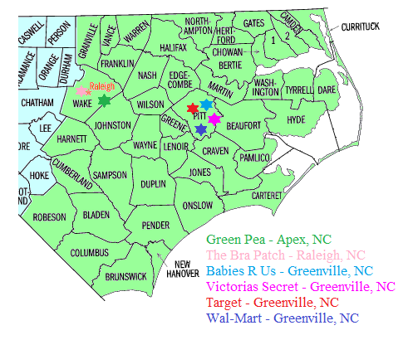
Table 1: Competitive Analysis
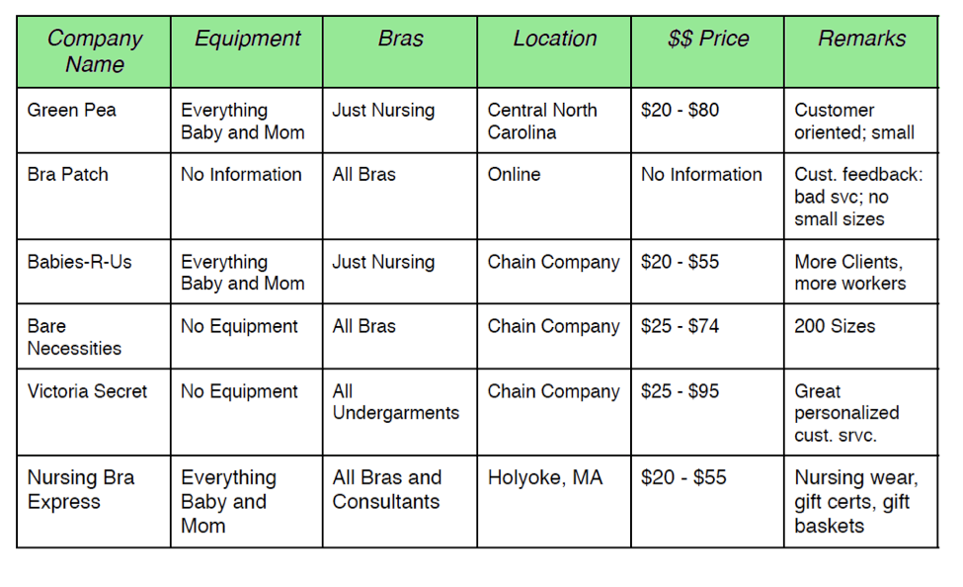
Green Pea® is located in Apex, NC, which is a suburb of Raleigh, NC. They offer a wide variety of clothing, furniture, décor, toys, diapers, breastfeeding accessories, and nursing bras. They also offer classes for new and expecting mothers on breastfeeding, cloth diapering, CPR instructions, breast pumping, selecting the correct nursing bra, and basics for baby care. The website for Green Pea is very impressive. All information on products including prices and sizes can be found on line along with online ordering and shipping. The website also includes a link to their Facebook page as well as a link to their blog which includes information on tips and deals on products.
The Bra Patch® is located in Raleigh, NC. They specialize in hard-to-fit bras, custom bras, bridal and formal foundation wear, maternity/nursing bras, bra fit accessories, sports bras, and prosthesis fitting bras. On their website, they advertise that they do custom fitting. On the website, they advertise celebrity endorsers of their products like, “We carry Le Mystere as featured in Oprah’s favorite spring things.” The website is orderly and attractive, but it is unfinished. When clicking on the links to see specific products, an “Under Construction” page comes up, so there is no information on sizes and prices. However, they do advertise that they have sizes for, quote: “EveryBODY.”
Bare Necessities® is a men’s and women’s underwear store with the closest location being in Asheville, NC. They carry bras, panties, sleepwear, clothing, and swimwear for their female customers. The website states that they have more than 200 sizes, but they do not carry any type of specialty or nursing bras. They also carry no breastfeeding equipment or any kind of equipment for new and expecting mothers. Because they are a chain store, it is safe to say that they are similar to a Target or Walmart, but they specialize in the fact that they carry more sizes of bras.
Babies-R-Us® is a chain store with the closest store located on Greenville Boulevard in Greenville, NC. Babies-R-Us is most likely the largest company that specializes in babies and new/expecting mothers. They carry a huge variety of baby accessories like strollers and car seats, furniture and clothing, and breastfeeding accessories. The store has a complete selection of breast pumps, nursing pillows and covers, nursing bras and pads, and other small breastfeeding accessories. The prices on these products are cheaper than smaller stores because they buy large quantities of these products so customers will usually find better deals at a chain store like this.
Victoria’s Secret® is the most renowned chain store in the underwear industry, and they have a location in the Greenville Mall. The chains “Pink™” line of clothing includes bras, panties, sleepwear, and swimwear. The website includes a full listing of the sizes the carry along with a feature called a “bra finder” and how to measure for what size to buy. There are no specialty bras and no products for new/expecting mothers.
The Nursing Bra Express® is the store most similar to Happy Girls and is located in Holyoke, MA. The website shows that they carry a selection of nursing bras, tank wear, nursing wear, and baby accessories. Also on the website, there is a variety of information and tips on breastfeeding. There is Frequently Asked Questions link on the home page, and when clicked on, it offers a long answer from a lactation consultant who is coined as their “expert.” The breastfeeding news section includes information on state laws and where to find the closest and best lactation consultant. Other extras included on the website are return policies, brands, customer service, and information on their small and large breastfeeding gift baskets which include a variety of breastfeeding necessities in a nice gift basket.

Strengths
One of the most valuable strengths of Happy Girls is the owner, Sophie Szymeczek. Mrs. Szymeczek has over 30 years of lactation consulting experience at Vidant Health®. The amount of experience she has opens so many more doors for this business than just retail. Many couples expecting children may be frightened at all the responsibilities of being a new parent. Through attending information session and scheduling consults, these expecting parents will be able to get a great value from Mrs. Szymeczek’s experience.
Other strengths of the store include the availability of merchandise, organization, customer service, high quality products, and uniqueness. The most unique of that group is the customer service. At other bra stores in Greenville, it is difficult to get help with fitting and hard to find the right bra in the first place. Because the owners are certified bra fitters, this makes the store unique in comparison to places like Victoria’s Secret and Target. Also, the ability for Mrs. Szymeczek to grow personal relationships with her customers is a unique strength.
Weaknesses
While her lactation experience is a tremendous strength, Mrs. Szymeczek’s lack of retail experience is the store’s top weakness. Weaknesses that stem from this are the lack of inventory control and knowledge on how to market and sell expensive breast pumps. Also, although the business not being in debt from start-up loan costs is a strength, the lack of financial tracking is a weakness. The only way the owners can track expenses is by looking through bank statements, which takes up time and is not as efficient as accounting software.
Opportunities
Happy Girls has the opportunity to increase their marketing presence through more advertising and attendance at local events. Many events that target young women, such as “In the Pink,” come to Pitt County each year. These events that promote things like breast cancer awareness can increase people’s awareness of what Happy Girls has to offer. Along with increased marketing and offering gift cards and coupons, there is tremendous opportunity for more people to hear about the store. As the store gets better known, more doors will open up to things like e-commerce that will help the business grow further.
Threats
There is an obvious external threat that can affect the success of Happy Girls in the form of consumer spending in relation to the economic climate. Other than that, the only threats toward the store are larger competitors like Babies-R-Us, Target, and Victoria’s Secret. Even though there are no other specialty stores like Happy Girls in Greenville, there is still a chance that one might go try out these other stores. Also, according to Mrs. Szymeczek, Vidant Health carries some items for new and expecting mothers. If the hospital chooses to expand their product line to the extent of Happy Girls, that could pose a major threat to the store.

STATEMENT OF OWNER’S OBJECTIVES
Since Happy Girls is a young business, most short term objectives are counted in months, and the long term objectives may be as close as a year. For that reason, there is not much discussion on objectives beyond 5 years. The goals provided are specific and realistic, that have a good chance of being of success.
Short Term:
- Establish a customer base of 500 customers in 2012, and add 5 customers per week in 2013 for a total customer base of 800 by end of 2013
- Have initial gross income from sales and rentals of $1,500 per month with growth of 20% in second year of operation
- Develop contractual relationships with two provider practices in 2012, with additional four relationships developed in 2013
- Provide and bill for 200 lactation consults in 2012, providing an estimated income from consults of $2,000
- Offer six new mothers, expectant mothers, grandmothers or couples breastfeeding information session/support groups in 2012 with an increase to 12 sessions in 2012
- Become better educated and have a better understanding of LightSpeed by the end of 2012
- Use QuickBooks to keep track of finances and inventory by the end of 2012
- Become efficient with inventory management and expand inventory by end of 2012
- Increase inventory of available sport bras by 50% in the store by the end of 2013
- Obtain and set up cabinets, drawers, and new racks to store and display bras in 2013

Long Term:
- Expand scope of sale to panties and bathing suits in the next 2 to 3 years
- Obtain and implement a mobile bra store-bus or van within the next 3 to 5 years
- Succession plan after Mrs. Szymeczek retires from the store
- Franchising the operation to different cities
- Store expansion
IDENTIFIED PROBLEMS

A full analysis of the business and industry has provided sufficient evidence to some issue within the business. These issues are listed below, with a brief explanation.
1.) Marketing. This seems to be the primary concern for the business. Upon entering the store, the layout seems to be in no particular order, and on top of that, a cluttered office space is visible. The building space has no closet for storing inventory so all inventories must be held off site or be put on shelves. The mirrors in the changing room are small and may make it difficult for a larger woman when trying on merchandise. Price tags are written by hand on each product, giving the store a “consignment” feeling.
When visiting the website and Facebook, some of the information is incorrect, out of date, or does not match. The website is also very basic and bland compared to other competitors in the industry. Lastly, an efficient marketing strategy needs to be implemented that is low cost but highly efficient.
2.) MIS. The tracking of important information is a key problem, predominantly vital customer information. The current POS system is adequate for gaining this information, but knowledge on using the system needs to be researched.
An accounting system also needs to be implemented in order to track finances in a more efficient manner. The store does have QuickBooks which can sync information with the LightSpeed POS system. However, knowledge on how to use both software systems needs to be researched.

RECOMMENDATIONS
The recommendation listed in this section come from extensive research of the business and the industry. Each recommendation goes in-depth with each identified problem, and explains the costs and benefits of each.
MARKETING RECOMMENDATIONS
In the five months of operations, the owners done a good job of initially putting their name into major Greenville media. There will always be people living in Greenville and eastern North Carolina that can benefit from the products that the store offers. When a successful marketing plan is implemented, there could potentially be more frequent customers. Because the store has little competition in its industry, there needs to be a strong effort to inform potential and existing customers of the unique and high quality products that the store offers. The following recommendation will focus on five important areas to improve the marketing impact of the store.

I. Target Market
Concentrating on a target market is important because it allows the marketing tactics to be aimed specifically towards a certain group of people, resulting in more efficiency in tracking customers. Having a target market leads to successful distribution and marketing of products. Following the patterns of certain groups can narrow a target market specifically, making sure that the product sold reaches the exact type of customer who matches it. Focusing on a specific segment can also allow owners to use capital in a more efficient way that cuts down on wasted time and money.
The typical customer consists primarily of pregnant or lactating women, considering that the main product line focuses on nursing bras and accessories. More specifically, these women should fall into the estimated age range of 25 to 40 years, which provides a large enough window for child-birthing. It may seem to extend rather far, but women have been increasingly starting their families later in life due to pursuing higher education and increasing involvement in their careers. Women with higher education benefit from higher income and thus can afford the products that Happy Girls offers. Families in the upper-middle class bracket have disposable income to use on amenities such as lactation pumps, pads, and nursing bras. Nuclear families, who own their own homes, are more likely to settle down and have children, and Happy Girls can benefit from marketing towards these homes.
According to data compiled during the July Census of Pitt County in 2011, there were 6,656 women 25-29 years of age, 5,886 women 30-34 years of age, and 5,302 women 35-39 years of age. This amounts to 17,844 women who fall within the approximate age range of Happy Girls’ target market. Having so many women who fall in the age range bodes well for Happy Girls. Also, being close to the largest hospital in eastern North Carolina poses a great advantage for Happy Girls. This provides high visibility to new mothers and other potential customers.
An additional focus on a more diverse segment of women should be targeted, since many women who may be well-endowed are neglected by traditional retail stores. More personalized attention from Happy Girls can help women feel welcomed and appreciated by the business. Women’s clubs such as the Brook Valley Hobby Club, Breast Feeders Support Group, and Women for Women can be contacted to establish a relationship. Groups such as these reach out to women in Pitt County and surrounding areas, and especially the Breast Feeders Support group would be very beneficial for Happy Girls to contact.
Estimates made in 2007 by the National Center for Health Statistics and the Center for Disease Control and Prevention state that over 60% of American women would be considered “plus-sized,” and roughly one-third of them are would be considered “full-figured.” Body weight plays a factor in the size and shape of a woman’s breasts, making it difficult for them to find brassieres that fit correctly. In Pitt County alone, 72.7% of adults are plus-sized or full-figured, making it apparent that there is a legitimate need for larger bras among women in the Greenville area. Yet it is important that promotions do not shed a negative light on the subject of a woman’s weight; rather, the company should fulfill their needs and offer guidance and a comfortable setting for these women to make their purchases.
It is difficult to reach out to large figured women because there are extremely few (if any) formal organizations dedicated to this market. An option would be to form a group where women could come into the store and talk about their experiences, and find acceptance—and a comfortable bra! Advertising for this group could be done in a similar fashion to the upcoming marketing tactics, not limited to radio, Facebook, or newspaper ads.

II. Product Mix
The product mix at Happy Girls includes a variety of items. The selection of products can be divided into four categories: bras (nursing and regular), breastfeeding accessories, health supplements, and clothing. The nursing bras are the most popular and best-selling product at the store. However, some customers come in and cannot find the perfect sized bra, or preferred color, and have to be placed on an ordering list. Along with nursing and specialty bras, breastfeeding accessories are the other important items in the product mix. Like the bras mentioned previously, these accessories are what the store specializes in. Once an inventory tracking system is in place, less money can be spent on low-demand items, such as clothing and health supplements, and more money can be put toward providing a larger selection of nursing bras and breastfeeding accessories. Also, by keeping track of the frequency that certain specialty products are bought, it may be easier to determine which products need more volume. The idea is that a customer will come into a store advertising specialty nursing bras and be able to find that perfect nursing bra on their first visit.
There seems to be a desire to expand the product scope of the store to regular, athletic, and training bras. This has to be done carefully because the typical bra is not the main focus of the business. These extra items may sell on occasion, but they cannot take precedence over nursing bras, atypical bras, and breastfeeding accessories. The definition of a typical bra would be a bra that someone can find at a Target or Victoria’s Secret, whereas an atypical bra would be one that is more than likely found at Happy Girls and nowhere else. If the owner would like to introduce just one of these items, it’s recommended to go with the athletic bras. Athletic bras would work only if a merchandiser is found that sells specialty sports bras that are not sold at stores in the Greenville area. This is because there is more opportunity with being able to sell atypical athletic bras to women who can’t find one at a typical store. Manufacturers that make atypical sports bras are Anita and Glamorise.
The affordability method of budgeting, which is a common marketing and supply chain model, should be used to determine what should be set aside for typical bras and clothing. The affordability method is implemented by first developing an overall merchandise budget, then determining how much needs to be spent each month on atypical bras in relation to customer demand, and then whatever money is left over should be used for typical products. In other words, you first purchase the products needed, and then purchase whatever can be afforded with the money left over. The idea here is that because customers are coming in because they require special products, they will leave the store with the specific product they are looking for. A customer will be more likely to return if they found a specialty product, rather than if they found a typical product that they can purchase anywhere else.
Evaluating other items that could be added to the product mix should also be determined. However, judging by the current cash flow, there is only so much expansion that can be done. It would also be hard to expand scope short-term because there is limited storage space. If recommendations are followed to purchase a means of inventory storage, space to put extra products should not be a problem up to a point.
Because breastfeeding pump machines have been difficult to sell, putting the machines up for rent could be a profitable option. At the moment, the machines are making no money for the store sitting on the shelf, but renting the machines out can bring more revenue in the long run than if the machines were actually sold. The idea is that mother’s will find it easier to make a small purchase in order to keep the machine short term, rather than making an expensive purchase for a machine that will stick around past its use. Other than renting out the machines, there are no other recommendations of increasing the product mix. Expanding the scope of products past specialty products may harm the business financially and may cause customers to see the store as nothing else other than a typical women’s clothing store.

III. Pricing
The pricing strategy is a significant component of the marketing plan for the business. Pricing of the merchandise can either attract or discourage potential customers who are in the target market. Understanding and implementing the pricing strategy is crucial for the business, because it can generate more revenue that will, in turn, allow for more funds to allocate towards the marketing strategy. There are a wide variety of products sold in the store, and most of the merchandise is currently being sold at the suggested retail price. At these prices, the profit margins for most items are at 50% earning the business an equal amount of profit relative to the product costs. According to market and industry research, we suggest that prices be raised on bras and keep the same prices for accessories.
The types of bras the business carries are extremely difficult to find in a physical location anywhere near Pitt County. Due to this, every bra is perceived by the target market as high in quality, not only for the material but for the convenience of allowing consumers to try them on before buying. Because of the uniqueness of the store and the consumer’s willingness to pay higher prices for the better quality, prices may be raised between 15%-20%.
Higher prices will give the business the flexibility to use pricing as a strategic marketing tool. One pricing strategy that could benefit the company is a sale where customers could buy two bras and receive one free. If Happy Girls has already implemented higher prices on their bras, the company will not lose money from the promotion and will gain more sales. This promotion gives customers a sense of saving money by giving away something considered valuable completely free, but the markup of each purchased bra will generate enough profit to cover the “free” bra. The promotion would require a purchase of two bras, which in turn will allow Happy Girls to get more products into the homes of consumers and may increase brand loyalty. Increased brand loyalty will create returning customers and word of mouth advertising could help drive business. This promotion is recommended due to the success it has had in similar stores around the region.
Another pricing strategy that can benefit Happy Girls is a seasonal sale, more specifically, a semiannual sale. Many small businesses similar to Happy Girls can implement a successful sale. If the store chooses to have a semiannual sale for example once in January and once in June, it will allow for customers to get a low price on their favorite brands and products. In turn, it will allow for more space and give the company a chance to bring in new merchandise for the following season.

IV. Placement
The location of the business is in a convenient location, directly across the street from the hospital. Adjacent to the store is a uniform store that sells nursing scrubs, making nurses aware of the business, and a steak and seafood restaurant on the other side. Though there are not many other retail stores in the area, there are many other medical service centers, banks, and restaurants just a short drive away.
Within the business, the layout of the store is rather small with an office, dressing room, and bathroom/storage room built in. Happy Girls has 376 square feet of selling space with only 193 square feet being utilized, leaving 183 square feet unused. Regular bras acquirer the most square footage of the store with 57 square feet, and accessories are a close second, accounting for 40 square feet of the store. Having a goal niche of being a breastfeeding bra store, Happy Girls nursing bras and maternity equipment should account for the highest square footage of the store, instead of 38 square feet for nursing bras and 16 square feet for health supplies. The look of the store produces an atmosphere of a consignment store. This is because there is no area to house inventory and all the products available are displayed on the floor. Coming in through the front door all the maternity, breastfeeding bras, and accessories are to the left of the store and all the regular bras and sport bras are on the right.
The division of breastfeeding and general products is beneficial to customers, yet the atmosphere of the store needs a more dynamic appeal. There would be more clarity if there were a long, narrow display table down the center of the store to better distinguish the maternity from regular, see Appendix A. In turn, customers will have a better idea of where to look in the store for what they need, whether it is a bra or equipment for breastfeeding or a regular bra for everyday life. A division table could also be used for displaying more bras and other products, as well as inventory storage if there were drawers or baskets underneath. This division would also create an obvious suitable section, in the regular bra side, for a larger sport bra selection. Currently, there is a small section dedicated to a minute selection of sport bras in the corner on the regular bra sector of the store. This area can continually be the placement of sport bras sense they are mainly an accent product and not the store main seller. This sport bra section also allows for growth and expansion in the store display as selection increases.
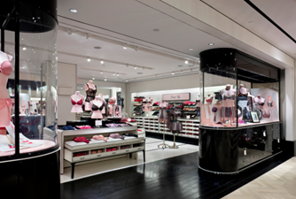
All products and inventory are displayed out on the floor on racks and hangers. The problem is lack of storage space and nowhere else to put extra inventory, which makes it difficult to order too many products in advance, see Appendix I. This problem is causing problems with housing all the bras their customers need and has created a waiting list for orders. Victoria Secret has established a great solution for housing its inventory out in the store. They use a variety of different tabletop displays, hanging displays (back to front and side to side), drawers, and mannequins as seen in (Figure 4). It would be beneficial to use more tables with draws/baskets for displays and inventory storage. Beautiful tables with drawers/baskets can be found at relatively low prices ranging from $100-$500, Ikea has tables with drawers for around $300 (Figure 5) and without drawers for about $180 (Figure 6), or find some online like at select2gether.com for $170 (Figure 7).
Figure 4: A Victoria's Secret Store
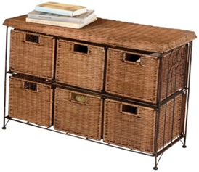
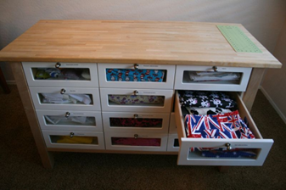
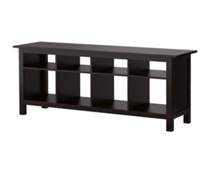
Baskets and sleek hangers could store and display the bras and would give the store a unique, attractive flare. Alibaba.com has baskets even with dividers for only $2.25, and Ikea has modern wood hangers for $.99 each. More mannequins need to be used in the store for better
display of the products. The store now has one or two mannequins to show off its bras but would benefit from more to show off the size variety it offers women. A women chest mannequin can be found for as cheap as $8 each at Display and Sound Control Essentials. To get an idea of what a display could look like, see Appendix A. Not only will these product display changes enhance the charm and attractiveness, but will also make it feel less cluttered and provide inventory storage.
Figure 5: Ikea Table without Drawers
Figure 6: Ikea Drawers
Figure 7: Select2gether Table
The office is in the back right corner of the store with a simple half wall and couch separating it from the rest of the store. Though it makes the store feel more open and bigger, as well as allowing the owner to always see who is coming in and out, customer are able to see all the cluttered paperwork and private business functions, see Appendix I. The office should not be seen by the customers, because it makes the store look unorganized and chaotic. A simple solution would be to drape fabric, like curtains, from the celling to separate the office from the rest of the store that still allows visibility to see the whole store when the curtains are pulled back. Another option would be to simply raise the wall a foot or so, to shoulder/chin height, which would hide the office clutter yet keep the office open to the rest of the store, see Appendix I. This would allow visibility of the entire store from the office but would prevent customers from seeing too much of the office space. This will help the store to appear much more professional and organized for customers.
Directly adjacent to the office wall barrier facing the front door is a comfortable coach and child play area. The social corkboard should be positioned on the wall in this area of the store, see Appendix I. Moms can send or bring in pictures of their babies and families to post onto this Happy Girl corkboard. This will create a set “family/children” area of the store, which gives the store a more family oriented feel that will easy to customers and bring more in.
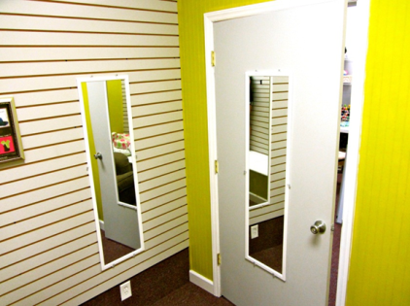
In the dressing room bigger mirrors need to replace the two very slim mirrors that are in place now. Bigger mirrors will make the dressing room seem larger as well as give customers a better view of themselves when being fitted and/or trying on bras. Two of the walls in the dressing room have a panels running horizontally up the wall
Figure 10: Small Mirrors
(Figure 10) which can be a huge benefit that should be taken advantage of. Currently there are only two or three hooks on the wall for hanging, but if shelve pegs or brackets were put in the panels the walls could be used as shelf space instead of empty space. Shelves in the dressing rooms would provide more storage and/or display space. By putting some of the clutter in the office and on the store floor into stylish boxes in the dressing room it would clean up the appearance of the store and the dressing room. The shelf space could also be used for more displays. Bras on chest mannequins demonstrated on the shelf in the dressing room would give some interesting detail to the bare dressing room and even encourage women to try on the bras displayed on the mannequins.
In the bathroom, there needs to be more shelving or cabinetry/armoire for storage. This will provide a better area for cleaning supplies, papers, any necessary storage boxes, as well as the sewing and embroidering machines. Storing some of the clutter in the office area, such as the embroidering supplies, will give the store a more professional look. It will also allow better organization to the office area making it easier to carry out the official operations.
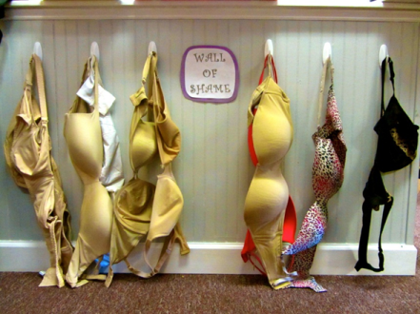
One of the more interesting and unique aspects of the store is the Wall of Shame (Figure 10). Currently it is low to the ground in the back of the store and barely visible. It has such an amusing appeal to it that the Wall of Shame should be displayed on the entire far back wall, so everyone can see it as they walk in. At the opposite side of the store, possibly near the front, there could be a showcase corkboard. This board could be used as a display for customer pictures, family pictures, newborn photos, or an information board.
Figure 11: Bra Wall of Shame

V. Promotion
Promoting any kind of business is no small task. However, the fact that there is no other store similar to Happy Girls in proximity to Greenville provides a great opportunity. Historically, Greenville is a college town with mainly students and older professors so neither group has much of a need for the products the store offers. However, Greenville has made improvements so it is now a more attractive place for families. This revitalization of Greenville makes the future of a specialty store targeted at new mothers a great opportunity, which should make advertising and promotion a top priority.
The focus that needs to be put on promotion is to encourage the customer to act now rather than later. The first task of marketing is to attract people into the store and the business already seems to have a loyal customer base. This customer base needs to be expanded through the use of different techniques of promotion. It is important not to abuse promotions, however, if promotions are over used, the value of the product will decrease. Promotions can be used for any store item and can be extremely effective if used appropriately as part of an integrated marketing communication program. If customers see the trend in coupons and promotions, it could be interpreted that those items are low quality. The customers will be more likely to wait by the door for their coupons on a regular day and not expect anything from the product. The consumers are encouraged to purchase a product by changing the desired behaviors.
In order to begin a promotional campaign and attract people into the store, it is important to understand one of the most effective forms of advertising, word of mouth. This is not something a business can put money into and expect results. Word of mouth advertising requires a great deal of reputation, trustworthiness, and differentially on the side of the business. Luckily, the target market is among the best word of mouth advertisers out there, young women. If a business can get a good amount of women excited about a group of products, then they will most definitely tell their friends.
In order to reach the previously specified target market, the business must understand who their customers are. Professional women are normally very particular about customer service and the quality of the products they are buying. The owners of the business must understand that every woman who walks into the store leaves with a smile on their face. All the recommendations mentioned above about product mix, placement, and pricing will come into play when handling promotions.
Some low cost marketing tools include Facebook and the company website. Though Facebook is a common major marketing tool used today, one of the first things customers look for is the company website. The store has a website, but it is very basic and limited. A company website needs to be more visually attractive and inviting. It can have other features if the owner does not plan on doing internet sales such as providing more information. Two ideas for the site are (1) including the price of breast-pumps and (2) the offering of breast-pumps for rent. Improving the website will help in business sales. The website can also include web promotions, such as with purchase of a breast-pump customer can receive a $25 gift card. The website page can be linked to Facebook, which will have both pictures of products and their prices.
With the goal of satisfying every customer, it is possible to use routine business practices to serve every customer in the best way possible. There is no simple way to make every customer happy because each customer is different, so the best way to start is within the store’s walls. The following are additional recommendations to consider.
Birthday & Mother’s Day Club: With a more efficient POS system in place (as outlined in the upcoming section), useful information and used for different promotional campaigns. Detailed information should be obtained should be used to the fullest. Birthdays and Mother’s Day is a good way to start these campaigns. Each mother could be given a long stem rose or carnation when they shop, and a small discount as well. The flowers can be ordered in bulk and the stores will offer wholesale prices. There are two online companies that were comparable in price. The first is www.flowerexplosion.com/wholesale-roses.html for 250 16-inch stems at $0.89 per, for a total of $222.50, and they are shipped by FedEx. The second company is www.fiftyflowers.com. Their offer is 30 Sunflowers at 7 days delivery, for a total of $89.99, and shipped by FedEx.
First, print out special Mother’s Day coupons attached to the stem of the flower, so if they do not use it, they can return to shop another day. Use paper, rubber stamps, and ribbons to make the coupons. These items can be purchased at Michaels Craft Store. Have the small coupons simply say, “Happy Mother’s Day! 15% off.” Remember that it is all about the experience when the customer comes into your store. Once you have a customer base and know their birth dates, offering a small rubber stamped card that says, “Happy Birthday - from Happy Girls, enjoy your gift card for $25.00.” Call the customer and let them know that you have a birthday gift card for them at the store.
Congratulations/Thank You Cards: In a small business, large purchases do not happen too often, so when it does occur the customer should be recognized. Any customer who purchases more than $350 should be mailed out a hand-written thank you card, along with an early notification of an upcoming sale. A strong bond can be formed between the business and the important customer when a handwritten note is sent directly to the customer.
If a woman comes in for the first time, it is critical to get the customer’s personal information in order to mail them a “Congratulations” card from Happy Girls. Also, if you know that a customer purchased an item from your store for the first time, after the customer personal information would be collected, send them a “Thank You” card for choosing your store. These two cards will go a long way with customers and give a great first impression of the store and its owners. With the experience of receiving cards from the store, the customers will tell their friends and their friends will tell someone else. The cost is minimal compared to the return from these gestures.
Loyalty Card: Another suggestion for promotion and advertising would be a Loyalty Card; a simple card that can be punched each time a customer visits the store. You can go to the website “123Print.com” and order 100 cards for $10.95, pick from 105 designs or personalize your own. Once the customer fills up the card they get a 50% off coupon, and they automatically become a “Preferred Customer.” The perks of a preferred customer could be that they get specialized treatment once every other month. A party can be thrown for all the preferred customers by having extended hours, music, and food just for them while they shop. Call the event, “Preferred Customer Mixer” or some other catchy name. A stamp can also be purchased at “123Print.com” When the card is filled up, mark that customers name in LightSpeed as “preferred customer” (which means that they filled up a loyalty card) and when the time comes to plan the party, mail them a personal, simply made rubber stamped invitation card. Make up a flyer to insert into the card that gives them information for the party: date, time, location, event information, food served, and percentage discount when they shop during the mixer.
Refer a Friend: When a customer enters a store, their first experience is extremely important. Be creative with promotions by asking regular customers to refer customers to the store. This could provide easy tracking by creating “Refer-A-Friend” slips for every new customer referred, offering a dollar amount or percentage discount. See the Appendix B at the end of the report for an example flyer of this promotion.
Fashion Show: A fashion show, just like Victoria Secret’s runway shows, could be a great promotional event. This could be an evening event at the Greenville Convention Center or rely on another event that is going on in town. Make sure to have models and mannequins for presenting and displaying the bras. The two bras to feature are the nursing bra and the regular daily bra. Have measuring tape ready and a pop-up dressing room for women to have privacy. Make sure to have plenty of inventory in order to sell products at the show. Suggestions for a show can be with the Maternity fair in April and the Nineteenth Annual "Making Pitt's Babies Fit", at the Greenville Convention Center. The purpose of the event is to help improve the health of Pitt County babies through the publicizing of available resources to expectant and new parents, individuals who are planning a pregnancy and new grandparents. The event will feature a variety of health exhibits, goods and services, a child safety seat clinic and a maternity and children's clothing fashion show. The general public is invited to attend and admission is free. For more information or to reserve exhibit space, call 252-902-2424, www.pittcountync.gov.
Sports & Sponsorship: Some unique ways to promote the business could be sports and sponsorship advertising. East Carolina University has a lot of women playing sports; advertise in the campus magazine when those events are in season. ECU students’ help with the Alzheimer’s walk to raise money, and the business could offer to sponsor a student or sorority to get the name advertised.
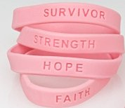
Breast Cancer Awareness Events: The event “In the Pink” passed recently and flyers were being handed out steadily to the public. Events are always a good place to promote a business. October should be the month to promote breast cancer awareness and have a fundraiser. Different ideas include: (1) a simple fundraiser out of the store by putting a “Big Pink” box for customers to make donations, (2) participate in a walk and raise additional monies and support by encouraging the customers to support the store’s efforts, (3) give a portion of sales proceeds by having a sale on an item, or donate a percentage of sales on a pre-announced day, (4) promote breast cancer awareness on the website and invite them to the store and give away support bracelets with each purchase. The price for 144 breast cancer awareness pink ribbon bracelets from Amazon is only $21.95. The costs for other bracelets range from $0.79 to $28.00; for other vendors, see the Appendix C for pictures of other styles. And lastly, decorate the front store window in pink. These ideas should become a yearly event for October.
Gift Baskets: Another method of promotion can be to make gift baskets for special occasions. Baskets can be made in various sizes, such as small, medium, large, and large for twins. Prices for the baskets could be from $125.00 to $175.00, depending on the contents. Items used to create the baskets can be bought at Michaels Craft Store, and the other items will come from the shelves of Happy Girls. These baskets could be offered for a baby shower gift or to say congratulations. In order to supply the mew mother’s breastfeeding needs, these gift baskets could include Earth Mamma Milk Made Tea, Nursing Pads, Nipple Butter, Bravado Body Nursing Bras, and any other items that would be excellent for a new mother. Appendix D contains examples of baskets ideas for this promotion.
Local Advertising: It is important that not only should there be advertising in Pitt County but also in the surrounding areas: Edgecombe, Martin, Beaufort, Craven, Lenoir, Green, and Wilson. For example, consider contacting the local newspaper (The Daily Reflector) to place an ad or a one-time promotional flyer. Make sure that the ad is available for “Black Friday” and just in time for Christmas. The radio is just as effective as the newspaper, so continue to take advantage of the promotional discount for $75 to get the store information on FM 94.3. Maybe the person that heard about Happy Girls on the radio will not need a nursing bra, but might share with their friends about information they heard. Word of mouth is very valuable in marketing. Table 1 lists some local businesses to advertise with:
Table 1: Local Marketing Contact Info
Business | Phone or Website
The Daily Reflector | (252) 329-9513
Convention & Visitors Bureau | (252) 329-4200
North Carolina Health Department | (252) 902-2955
Pitt County Office Park | pittcountync.gov/depts/health

Strategic Partnerships: When circulating marketing materials to doctors’ offices, be sure to follow up on another day to make sure that the appropriate people received the information. Or better yet, a meeting can be arranged with the doctor’s public relations contact or the office manager. Ask if they can include Happy Girls information in their publication or at a minimum keep a brochure/flyer/business card in their lobby. It is important to build a relationship with surrounding OB/GYN offices since they have direct contact with expecting moms. Make sure to contact and establish relationships with OB/GYN, General Practitioner, Mastectomy, and Breast Cancer Clinics. When the time comes, place an ad in the Hospital Book - “Beginning Life w/ Your New Baby” (area resource list); this will be in the 4,000 books they publish; do not miss this opportunity for advertising. Anything to do with the hospital regarding advertising will be a plus for Happy Girls, so staying in contact with past employees is important for business.
The Women for Women organization can provide a very valuable social connection with the women of Pitt County. The organization reaches out and influences many women and girls in need. They accept grant applications from non-profit organizations in Pitt County between July 15th and August 31st. The businesses mission statement and heartfelt commitment to raise awareness about breastfeeding could receive some amount of funding from members of Women for Women. Their website lists contact information and a link to their page on Facebook that could connect the store to other women’s groups in Greenville. There is also an annual luncheon held by the organization called “Power of the Purse,” where an inspirational speaker addresses the attendees.
Calendar: Selling calendars with specific coupons for each month as another promotional recommendation. A suggested sale price for the calendar will be $20 for one book. The top portion of the calendar will show a collage of baby pictures. The baby pictures in the calendar can be selected by a contest on Facebook to see which pictures get the most “likes.” The most popular pictures will be put in that calendar, making the mother’s more likely to purchase a calendar or tell their friends/family about it. Examples of the calendars can be found in Appendix E.
When a customer buys a calendar, they will go to a month and see that the specific event for that month; perhaps “Gym Month” is the theme for January since research shows that gym memberships often triple that month. The customer will bring in that coupon and get a discount on sports bras. The next month is February so the event for that month can be “Valentine’s Day”. Each page will display the predetermined event and perforated coupons to correspond to that month. Sophwell is a firm that will custom make promotional calendars. Their information is: Sophwell 10 Tower Office Park Suite 406, Woburn, MA 01801, phone: (781) 281-1430, email: info@sophwell.com.
Place Advertising: Place advertising is putting advertisements and promotions and areas that potential consumers will most likely pass by and see. This can be done by placing brochures, flyers, and business cards at churches, homeless shelters, unemployment office, community centers, day care centers, and military welcome centers. Also look into contacting local churches like the Koinonia Christian Center Church. Ask the churches if an ad can be placed in their church bulletin. Once permission is granted to promote the business in the church, continue on to the next church. More church information is included in the Appendix F. The community center is also a great location because they have a “Breastfeeding Month” that is already a part of their services. The center’s email is www.greenvillenc.gov. Further information on “Breastfeeding Month” can be found in the Appendix G.

Management Information Systems Recommendations
Tracking inventory and customer sales are important to the success of any business. Good inventory practices allow a business owner to keep track of inventory, goods sold, and the inventory turnover of different items. An effective management information system can help a business organize information and use it to make more effective decisions. One specific group of important data is customer sales information. Benefits from tracking customer sales include an understanding of where customers are coming from, what their age is, and what sizes they are. Other benefits can include information on which months sales are slow and what items are best-selling during certain parts of the year. Using this kind of seasonal information can help set dates for promotional events for customers. The following are recommendations that include options of different approaches, which can be used to ensure the management information system and the POS environment are efficient and able to work together.
Below are four steps to improving the operations of the business. The steps are listed in the order that they should be implemented. These recommendations will improve decisions in dealing with sales, inventory, customer tracking, and financial statements.

I. Point of Sale System
LightSpeed seems to be the typical point of sale system for running the business, so it is very important that time is taken to make sure that systems is studied and used to its fullest capacity. LightSpeed allows the user to check their customers out and purchase a product. It also has a system where you can track all customers and the system keeps track of inventory. With all these features available it is recommended that this system is utilized. Using the iPad is fine for doing business; in fact, other companies use it as well. Other companies also use the cash register that LightSpeed offers. This can be purchased for approximately $290.00. Other items that might be useful are the Receipt Printers $373.75, Bar Code Scanner $269.00, Card Swipe $79.35, and Intelli Scanner $299.00. Intelli Scanners’ rechargeable laser barcode scanner can store barcodes, slashing the time it takes you to count inventory, enter and receive POS, or invoice products. These LightSpeed products would be a good investment and can be purchased on the LightSpeed website or on websites like Amazon. A good inventory tracking system accomplishes four things: (1) it shows what merchandise is in stock, (2) it shows which items are on order, (3) it notifies the retailer when ordered merchandise is scheduled to arrive, and (4) it tells what merchandise has been sold.
A large part of our recommendations regarding pricing is focused on the barcode system the company is using. Currently being used is a hand written price tag that includes the price only. If the company can implement a barcoding system, it will allow a better opportunity to know exactly what and how much of a particular item is in inventory. If linked with LightSpeed technology, it would greatly increase the efficiency of operations and inventory management. One of the most affordable, easy to use, and compatible barcode scanners around has been the IntelliScanner.
As quoted, the IntelliScanner would cost $299.00 and works with a Mini USB Cable connected to the company’s iPad. For the price, a business integration kit is included and explains how to integrate the LightSpeed software. As for the tag tape needed for implementing the system, an asset tag pack of 100 costs $24.00. Also available is the option to buy in bulk. Five-hundred asset tags costs $79.00, so depending on merchandise flow within the business may determine the correct amount of tags needed. Because the inventory currently within the business is fairly small, the cost to keep up and tag new merchandise will not be financially unfeasible.
II. Inventory System
A business owner needs to identify the inventory system that works best for the business needs. Appropriately managing inventory can be the difference between revenue surplus or loss of business and sales. Inventory is the main focus of retail business, and poor inventory management will eat away at profits, cash flow, and waste employees’ time.
Currently, the business does not use an efficient inventory system. Hand written price tags are being used for every product with no way of keeping track of inventory besides brain memory. The owners already have inventory software called LightSpeed on their laptops, once learned, this software can be used to quickly see what’s been sold, the quantity, and on what day. This software can also be used in conjunction with a barcode scanning system.
A barcode system automatically keeps track of inventory after every purchase and sale. A barcode scanner can be found incredibly cheap on Amazon, ranging between $20.00 and $30.00. Once the scanner scans the barcode of each product, it goes straight into LightSpeed while changing the amount of inventory for that specific product. LightSpeed will keep track of the entire inventory automatically instead of having to remember what items were sold that day, week, month, or year.
This method of tracking inventory will give an exact number of how many items were sold in a giving time period and make it clear what items need to be restocked. Not only will barcoding and LightSpeed show what needs to be purchased from the manufacturer, it will also clearly show trends. It will give a precise and clear indication of what items are flying off the shelves and which has been collecting dust in the store.
For a small retail business it is important to have a target level at which a re-order should be made and how long it has been in the store. This next step is critical: check to see if the item sold when expected. If an item sits on the floor or back in inventory, the tracking system will help develop trends. If an item is found to be selling fast, then there is a need to double the re-order quantity. If an item has not sold since it was placed out on the floor or ordered, then consider discontinuing carrying that item altogether. This trend needs to develop in order to make sure capital is not tied up in too much inventory. These trends will allow recognition of stock and can be used to the store’s advantage by having quantity discounts with those extra items.
A system or procedure needs to be put in place to have a smooth inventory control. Start by developing a “check-in and check-out” system whether writing it down or directly logging it in the database; for procedures to be followed they must be simple, consistent, and accurate. Once an order comes in make sure to do an inventory count, check the database to assure the quantity ordered is correct with what was received. Once a year it is a good idea to do an inventory hard count on all products. This makes sure that all items are accounted for. It is recommended that the store closes for a day, like MLK Day when store’s usually close, and conduct this hard count.
Even though checking that inventory is verified with each shipment that comes in and the database has a system that tracks re-order quantity levels, it is still important to annually or semi-annually count inventory manually. This annual count will make sure that the system/procedures for inventory are still effective and can catch problems that otherwise would not have been found. Once inventory is manually counted, those numbers should be compared to the database numbers. The largest cost for retail is inventory, which is why it is important to have procedures.
The challenges of inventory tracking can be managed with planning, organization, and consistency.

III. Collecting Customer Information
Detailed customer information is a valuable tool for any business, because it helps to predict how trends will flow in the future based on what customers bought in the past. Happy Girls currently has the capability to record and document such information through its point-of-sale software, LightSpeed. A simple way to acquire the information of their customers is to collect when they make their purchase. Demographic information, such as address and age can help narrow the target market; while information on each customer’s bra size will give the store a better idea of the order quantity of each bra. The frequency of purchases by a repeat customer can be tracked through LightSpeed as well, which will aid a preferred-customer marketing tactic. The customers’ addresses, e-mail addresses, and phone numbers will allow employees to contact their clientele and provide news updates, coupons, and special offers in a more personalized manner. LightSpeed tracks the frequency of purchases by a repeat customer, as well, which will aid preferred customer marketing. Effectively, this should build customer loyalty and enable the store to host preferred customer mixers.
Figure 1: Example of a Customer Survey
The employee checking out the customer during checkout should check to see whether or not the database contains their information. If not, they should give the customer a survey, like the one in Figure 1, and enter the customer information into the LightSpeed POS. Giving out personal information can be a tentative issue for certain people, and the business should assure that each of their customers feels comfortable sharing this information. The following table is an example of what this customer information survey should look like:
Want to be and even Happier Girl?
Become a preferred customer and be the first to know about our upcoming promotions, events, and exclusive preferred customer only coupons.
Name______________________ Phone_______________________
Home Address___________________________________________
e-mail_________________________________Bra Size___________
What other products would you like to see at this store? _______________________________________________________
How did you hear about the store? _______________________________________________________

Promotions could easily be distributed via email to each customer who provides their information. E-mail based promotions are successful mainly because they are a free avenue of advertising, and most people have an email address they use daily. Figure 2 is the procedure that should be followed when collecting customer information:
Figure 2: Procedure for Collecting Customer Info
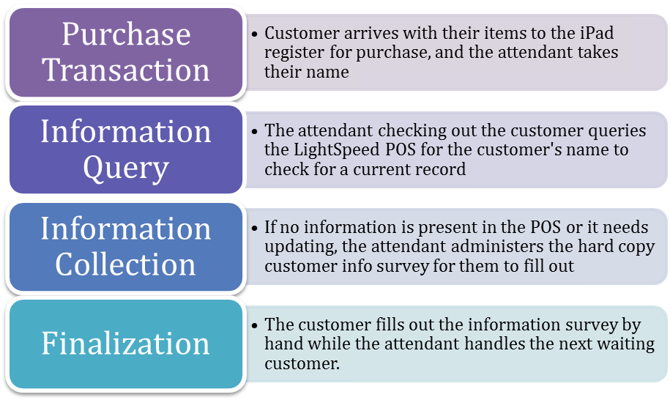

IV. Financial Efficiency
The financial statements of a business are often referred to as the “language of a business.” A business owner should be able to “speak the language” of their business by making sure they understand all financial statements. This important for a business for tax purposes, and loan purposes, but can also put less stress on an owner by giving him/her the state of mind that they have finances under control. Familiarizing with QuickBooks will provide a more detail understanding of the financial standing. The accounting software has three main advantages that make small businesses more effective. The first, and most important, is that the program has the capability to help make better decisions that can lead to increased profits. Different financial reports can be created to view how much money is gained or lost during a period of time or how much money has been spent in a specific area. These reports show where the money is being spent, customer history, and which course of action can be most profitable. Second, the program saves time. At this moment, one has to dig into pages of bank statements to do bookkeeping or put together important information. When the software is learned, hours of time can be saved each month by doing everything with just a few clicks.
Finally, QuickBooks allows a business to be more organized. The software allows users to view their company’s complete financial history. The program includes how much of a product was sold, how much is in inventory, and eliminates the issue of buying too much or too little products. There is also a feature that reminds owners when it is time to reorder certain products. All three of these features cut down on the stress of operating a business that has minimal employees and little business background. Once this software is learned and implemented, the store will most certainly be more efficient in nearly all aspects.

COST ANALYSIS
Marketing Budget
It is recommended that long-term spending on marketing should follow a percentage-based and fixed budgeting plan. Based on the expenditures of the store in the first months of operations, it is apparent that between 5% and 10% of cash revenues are spent on marketing. Based on these figures it is recommend that 7% of the previous month’s revenues be set aside for marketing costs in the current month. Long-term, this budgeting method could be implemented using financial figures from the previous year or past sales volume. The idea is that the marketing budget stays variable with how much revenues are coming into the store. However, it is very important to know that this can also hinder a small business if one is not careful. Small businesses tend to spend less on marketing when sales are low. This can financially harm a business because when sales are low, marketing is needed more than ever. For this reason, a fixed method of budgeting is also recommended in the event that revenues are low in the previous month or previous year. This method ensures that there will always be a minimum amount spent on advertising each month even if sales decline for a short period. An amount of $700 has been determined to be the fixed minimum amount budgeted. To put it more simply, if revenue for the previous month is greater than $7,000 then the percentage-based method should be used. If revenues are less than $7,000 then the fixed amount of $700 should be budgeted.
A short-term budget for improving the atmosphere and placement of items in the store has been determined to be $500. Items included in this budget are the new dressing room mirrors, display corkboards, cash safe, office barrier, mannequins, and storage cabinets. As shown in the table below, a total of $290 should be budgeted on these items for the rest of the year, then $90 for the 1st quarter of 2013, $150 for the 2nd quarter of 2013, and then $600 for the 3rd quarter of 2013.
Table 2: Marketing Implementation and Cost
Item | Implementation | Cost
Dressing Room Mirrors | Now | $240 (for two)
Display Corkboard | Now | $50
Cash Safe | 1st Quarter of 2013 | $90
Office Barrier | 2nd Quarter of 2013 | $100
Mannequins | 2nd Quarter of 2013 | $50 (for two)
Storage Cabinets | 3rd Quarter of 2013 | $600 (for two)

MIS Budget
Fortunately, most recommendations for the improvements of the information systems are long-term and come at a low cost. Until the fourth quarter of next year, most of the funds available to improve the business should go towards marketing. The only thing that should be budgeted now is time to master LightSpeed and QuickBooks software. The only money that needs to be spent on MIS recommendations is funds for collecting customer information. Small survey slips are cheap and easy to make since only a few sheets of paper each month and ink in the printer are needed. It is not until the fourth quarter of next year that funds are recommended to be budgeted towards MIS, for the items: barcode scanner, labels, receipt printers, card swipe, and a cash register. The cash register is the only item that is recommended to be viewed as optional. It is recommended that these items be purchased only after enough funds are available and all inventory software is mastered. Therefore, the timeframe in which this plan should be implemented is during the fourth quarter of 2013. Table 5 shows the prices for the recommended items:
Table 3: MIS Implementation and Cost
Item | Implementation | Cost
Info Cards | Now (recurring) | <$5
Card Swipe | 3rd Quarter of 2013 | $80
Labels (100) | 4th Quarter of 2013 (recurring) | $25
IntelliScanner | 4th Quarter of 2013 | $300
Receipt Printers | 4th Quarter of 2013 | $375
Cash Register | 2014 | $290

IMPLEMENTATION SCHEDULE
The timeliness of implementing each recommendation is important to the success of any business. Keeping an organized schedule of when to research and start implementing recommendations ensures that each item is done within the financial constraints of the business. It is a good practice to follow these steps and possibly add items to this list down the road. The schedule breaks up the recommendations by quarter and for future years. The steps are listed in the order that they should be implemented. This schedule will organize decisions in when to start researching, when to make space in the budget, and when to finally implement the idea.
Tasks to be implemented during the remainder of 2012:
Table 5
Research Events | Find Pitt and surrounding county events that relate to the industry, in order to participate in them as soon as possible, to get the name out.
Advertise in Churches/Daycares | Many moms, new moms, and soon-to-be moms congregate and take advantage of these services, making them perfect promotional locations. The sooner the name gets out, the better.
Raise prices on bras (15-20%) | As a specialty store, and the only one of its kind in its area, raising prices is necessary. Higher prices will give a high-quality atmosphere. This needs to happen now while still a young business with a small clientele.
Bigger mirrors in dressing room | Bigger/more mirrors in the dressing room will enable customer to better judge the way they look in a new bra. This needs to be done soon so that customers will be less frustrated and more willing to be fitted/try on bras in the dressing room.
Showcase Chalkboard | This will inform customers of any events, specials, and discounts provided that day/week/month. Due to present event and promotions in progress, this needs to be done as soon as possible.
Reposition “Bra Wall of Shame” | This is an amusing aspect of the store and needs to be better visible. It will draw customer’s attention and encourage them to add their own dysfunctional bra.
Give out customer information cards | One of the best ways to gain customer information and begin a customer database. Once put in place, the database can be used for promotions and to expand their clientele.
Master LightSpeed and QuickBooks | These are the backbone of a business financials, keeping all assets, liabilities, inventory, profit, bills, and customers in order. The sooner there is an understanding the business will become more profitable.

Tasks to be implemented during the First Quarter (Jan-Mar) of 2013:
Table 6
Research/Planning for half-wall office barrier | There needs to be some separation between the store floor and the office. Still too young with not enough financials in Q1 to purchase, but now can be a time to begin preparation for purchase later in the year.
Thank You and Congratulations Cards | Find out the women currently pregnant through communication with the hospital and OBGYN. This is a good way to inform women at the beginning of their pregnancy of the store to gain clientele.
Birthday Promotions | After developing a suitable customer database send out birthday promotions. This will remind customers of the store, give them a sense of importance, and hopefully bring them back to the store.
Cash Safe | The cash box used now is fine while the store is still new; however, as the store grows with more transactions and more cash, the cash needs to be kept secure if there will not be a register.
Implement New Budget | By the end of Q1 there should be a clear flow of what is needed to be purchased regularly and only once. This will set the purchasing schedule for the rest of the year or more.

Tasks to be implemented during the Second Quarter (Apr-Jun) of 2013:
Table 7
Install half-wall office barrier | By Q2 there should be enough profit to have money left over to build the office wall. This is one of the first major purchases to improve the store’s look to make the store more appealing to the customer eye.
Research and planning for cabinets | The next big purchase for the store is new cabinetry for the floor. Since in the same quarter, the new office barrier should be put into place, while beginning research of new cabinets/shelving for the products.
Mannequins | Will help with displays and marketing specific bras to customers and add interest to the store. This should be done in Q2 because they are not a necessity to run the store but will help sell the products.
Mother’s Day Coupons | Q2 includes mother’s day, and being a breastfeeding bra store, a promotion is necessary.

Tasks to be implemented in the Third Quarter (Jul-Sept) of 2013:
Table 8
Storage Cabinets | The cabinets for the floor need to be purchased and put into place to give the store a better-organized, clean atmosphere. There should be enough left over profit by Q3, especially after the preparation in Q2, to make the purchase
Card Swipe | Once there is growth and profits (after about a year in business), manually entering card numbers will become time consuming.
Tasks to be implemented in the Fourth Quarter (Oct-Dec) of 2013:
Table 9
Refer a Friend | After one year, there should be enough customers in the database. Implement this promotional technique to expand the database even more.
Breast Cancer Awareness Events | Breast cancer awareness month falls in Q4, where the business needs to have an event or jump on with another for promotion.
Barcode Scanner & Labels | By Q4, there should be enough inventories that hand written labels will become tedious, redundant, and take too much time. Barcodes and scanners will automatically keep track of inventory and make inventory procedures faster.

Tasks to be implemented in 2014:
Table 10
Market research on mobile consults and fittings | Once the store is fully up and running with a stable client base for a year, research on consults and mobile consults and fittings should be done.
Preferred customer mixer | Once there is a substantial customer database with returning customers who are able to become preferred customers, there should there be a mixer for more promotion and reemphasize customer relationships.
Happy Girls Calendar | A calendar is a great promotional tool, but the business needs to have a stable customer base that would be interested in the calendar and spare money for the cost of the calendars.

Tasks to be implemented in 2015:
Table 11
Expand product scope (bathing suits and athletic bras) | Only after the business has prospered with just bras should there be expansion into other industries. Doing so too soon could cause store clutter and customer confusion as to the products.
Mobile consults and fittings | Only after success as a stationary store should there be a mobile store. Doing so earlier will take away attention needed for the store.
Fashion Show | Once a name is made in the community with strong relations with suppliers can there be enough support for a fashion show.
Sports and Event Sponsorship | Sponsorships are a great for promotions however cost money and cannot be done until the business has a steady income and an elastic profit.

CONCLUSION
On behalf of the Small Business Institute® at East Carolina University, we would like to thank Ms. Sophie Szymeczek and Mr. Steve Minor for allowing us the opportunity to work with their business. This process has allowed us to better learn the foundations of starting and operating a small business. It has been a pleasure working with everyone and we could not have asked for more welcoming and helpful client to learn from and provide assistance.
The recommendations in this document cover two main areas; marketing and management information system. Collecting customer information, learning the POS software, and tracking inventory are critical to the future success of Happy Girls. With an effective database of customer information, marketing efforts can be specialized towards consumers that are more likely to need what Happy Girls has to offer.
Maintaining the current scope and then slowly expanding scope long-term will help keep the store more specialized than larger retail stores. Being a specialty store, and the only one in this industry in the area, provides the flexibility to raise prices and offer more promotional deals. Improved placements of items and storage will ensure that the store space is being used to its fullest capacity. Finally, promoting the store throughout Greenville and the eastern part of the state will increase the customer base as well as make shopping at Happy Girls more enjoyable.
If the recommendations are implemented correctly the store will hopefully experience an increase in cash flow and customer traffic. Eastern North Carolina needs a specialty store of this nature, but more customers need to be aware of the product offering. It is our hope that our recommendations will help the business grow and achieve an even greater level of success.

REFERENCES
"Baby Registry, Baby Gifts, Car Seats, Strollers & More." Babies"R"Us. Geoffrey, LLC, n.d. Web. 26 Nov 2012. <http://www.babiesrus.com/shop/index.jsp?categoryId=2255957>.
"Bare Necessities." Bare Necessities. BareWeb, Inc., n.d. Web. 26 Nov 2012. <http://www.barenecessities.com/>.
"Bras for Everybody." The Bra Patch. The Bra Patch, n.d. Web. 26 Nov 2012. <http://www.thebrapatch.com/>.
"Buy Nursing Bras, Breastfeeding Bras, Covers and Breastfeeding Accessories Online." Nursing Bra Express. The SEO Company, n.d. Web. 26 Nov 2012. <http://www.nursingbraexpress.com/>.
"Evolve Your Store Retail Enlightenment." LightSpeed Retail Point of Sale. LightSpeed Retail Inc., n.d. Web. 26 Nov 2012. <http://www.lightspeedretail.com/>.
"GreenPea Baby & Child." GreenPea Baby Boutique. GreenPea Baby. Web. 26 Nov 2012. <http://www.greenpeababystore.com/>.
"Lingerie and Women's Clothing, Accessories & More." Victoria's Secret. Victoria's Secret, n.d. Web. 26 Nov 2012. <http://www.victoriassecret.com/>.
Lozada, Adriana. "Babies are being born pre-polluted." Birthful. Birthful, n.d. Web. 26 Nov 2012. <http://www.birthful.com/category/greenproofing/>.
"Maternity Clothes, Women's Maternity Clothing & Maternity Wear." Motherhood Maternity. Motherhood Maternity, n.d. Web. 26 Nov 2012. <http://www.motherhood.com/>.
"Nursing Bras." breastfeeding-mom.com. N.p.. Web. 26 Nov 2012. <http://www.breastfeeding- mom.com/nursing-bras.html>.
Perry, Phillip. "Beating the Big Box." Specialty Retail Report. Specialty Retail Report, n.d. Web. 26 Nov 2012. <http://specialtyretail.com/issue/2002/10/retail-staffing-and- hiring/beating_big_box_stores/>.
Pickert, Kate. "The Man Who Remade Motherhood." The Origins of Attachment Parenting. Time Magazine, 21 2012. Web. 26 Nov 2012. <http://www.time.com/time/magazine/article/0,9171,2114427,00.html>.
Szymeczek, Sophie. "Happy Girls Bras and Breastfeeding." Happy Girls Bras and Breastfeeding. Facebook, n. d. Web. Web. 26 Nov. 2012. <https://www.facebook.com/HappyGirlsBras>.
Szymeczek, Sophie. "Happy Girls Bras and Breastfeeding." Happy Girls Bras and Breastfeeding. Wordpress, n. d. Web. Web. 26 Nov. 2012. <http://happygirlsbandb.com/>.
"What is Quickbooks?." QuickBooks. Intuit, Inc., n.d. Web. 26 Nov 2012. <http://quickbooks.intuit.com/what-is-quickbooks/?sc=BNR-000-COR- quickbooks_Exact&cid=ppc_google_QB-Intuit-Core- Brand_quickbooks_exact&priorityCode=4902000000&pn_override=SearchRC_landing_ gen&adgroup=General_QuickBooks&ad_id=18631020608&raw_keyword=quickbooks>.

APPENDIX
Intentory Storage …………………………..…………………………………..… A
Refer-a-Friend Slips ……………………………………………………………... B
Ads Related to Breast Cancer Awareness …….………………………………….. C
Gift Baskets ………………………..…………………………………………….. D
Promotional Calendars …………………………………………………………... E
Local Churches …………..……………………………………………………….. F
City Ordinances Related to Breastfeeding ………………………...……………... G
Brochure Example ……………………………………………………………..… H
Pictures.......................................................................................................................I

APPENDIX A: INVENTORY STORAGE

Below is a possible floor plan of the store with the recommended storage units:

Floor Plan Key

A. Work/office desk
B. Shelves
C. Refrigerator
D. Table
E. Raised office barrier
F. Mirror
G. Center storage/display table
H. File cabinet
I. Bench
J. Storage/display tables (reference picture A)
K. Stand alone display rack
L. Front display counter
M. Wall rack/hangers
N. Children area
O. Possible placement for corkboard

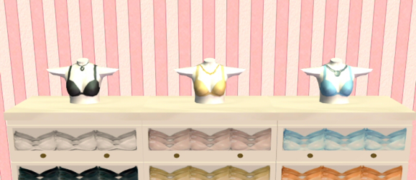

APPENDIX B: REFER A FRIEND SLIPS

APPENDIX C: ADS RELATED TO BREAST CANCER AWARENESS

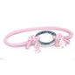
Breast Cancer Awareness...
$2.07
PartySupplie...
Pink Ribbon Band Bracelet
$0.79
CenturyNov...
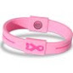
EFX Breast Cancer Awar...
$17.95
SwimOutlet.c...
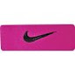
NIKE Swoosh Pink Cancer...
$4.69
Epic Sports
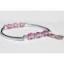
Be Aware Bracelet ‑ Br...
$15.00
Choose Hope
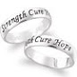
Sterling Silver Breast Canc...
$19.99
Limoges...
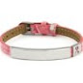
Engravable Pink Leather...
$28.00
Eve's...
Breast Cancer Awareness...
$5.00

APPENDIX D: GIFT BASKETS

APPENDIX E: PROMOTIONAL CALENDARS

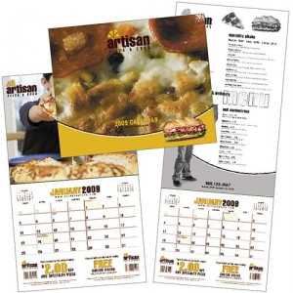

EVERYDAY DEALS
Custom Coupon Calendars
Retailers rely on repeat business. This 12-month appointment calendar allows you to offer tear-off coupons at the bottom of each month for a lasting impact. Based on a stapled 12-month appointment calendar; memo-style grid with perforated coupons on the bottom on each month. With a fold-over cover, printed with a four-color photo. Create a one-of-a-kind, custom calendar, the possibilities are endless!

CALENDAR | Yearly PROMOTIONAL EVENTS
JANUARY | Gym - Fitness - Memberships (Target Audience)
FEBRUARY | Valentines Day - Everything is RED
MARCH | St. Patricks Day - Everything is GREEN
APRIL | Maternity Fair: Bravado Designs: purple, pink, black, ivory, beige. Order extra inventory for this event!!!
MAY | Mother’s Day - Single Flower w/ coupon attached. Grandmother’s Tea Day
JUNE | Daddy Boot Camp slogan can not be used?!!! Re-name - Happy Dads or Spring Training for Dads
JULY | 4TH of July - Everything Red White & Blue. Also, Vacation Time
AUGUST | World Breastfeeding Month - NCBFC.Org “North Carolina BreastFeeding Coalition - Ban the Bags Packet
SEPTEMBER | Back to School for kids - Back to School for MOMs
OCTOBER | Breast Cancer Awareness Month - Everything is PINK
NOVEMBER | BLACK FRIDAY - prep for day after Thanksgiving
DECEMBER | Christmas

APPENDIX F: LOCAL CHURCHES

Surrounding Pitt County Missionary Baptist Churches in Your Local ...
www.yellowbook.com/yellow-pages/?...baptist+churches...pitt+count...
Results 1 - 10 of 21 – Surrounding Pitt County Missionary Baptist Churches ...
Cherry Hill Missionary Baptist Church
5050 Weaver Rd
Wilson
Cherry Hill Missionary Baptist Church
3349 Cherry Hill Church Rd
Tarboro

People's Baptist Church
peoplesbaptist.org/
Google+ page
1621 Greenville Boulevard Southwest
Greenville
(252) 756-2822

Winterville Baptist Church
www.wintervillebaptist.org/
Google+ page
2593 Church Street
Winterville
(252) 756-5955

Unity Free Will Baptist Church
www.unityfwb.org/
Google+ page
2725 East 14th Street
Greenville
(252) 756-6485

Arlington Boulevard Baptist
arlingtonboulevardbaptistchurch.com/
Google+ page
1007 West Arlington Boulevard
Greenville
(252) 756-2122

Black Jack Free Will Baptist
www.blackjackpfwbchurch.com/
Google+ page
2972 Black Jack Simpson Road
Greenville
(252) 752-6485

First Baptist Church
www.fbcrobersonville.org/
Google+ page
208 Northeast Railroad Street
Robersonville
(252) 795-3601

Providence Baptist Church
plus.google.com
Google+ page
More results near Pitt, NC »
300 East Purvis Street
Robersonville
(252) 795-5365

APPENDIX G: CITY ORDINANCES RELATING TO BREASTFEEDING
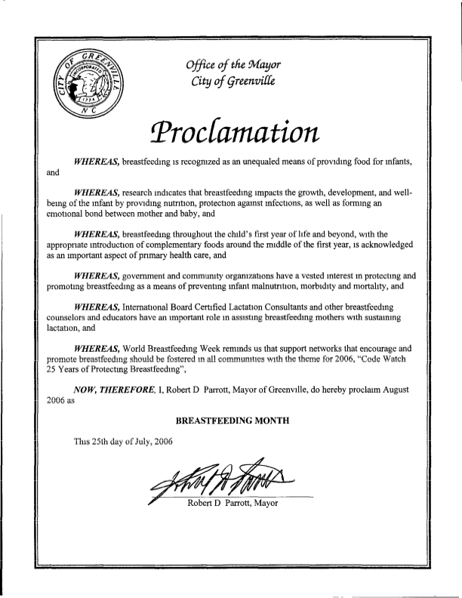

APPENDIX H: BROCHURE EXAMPLE

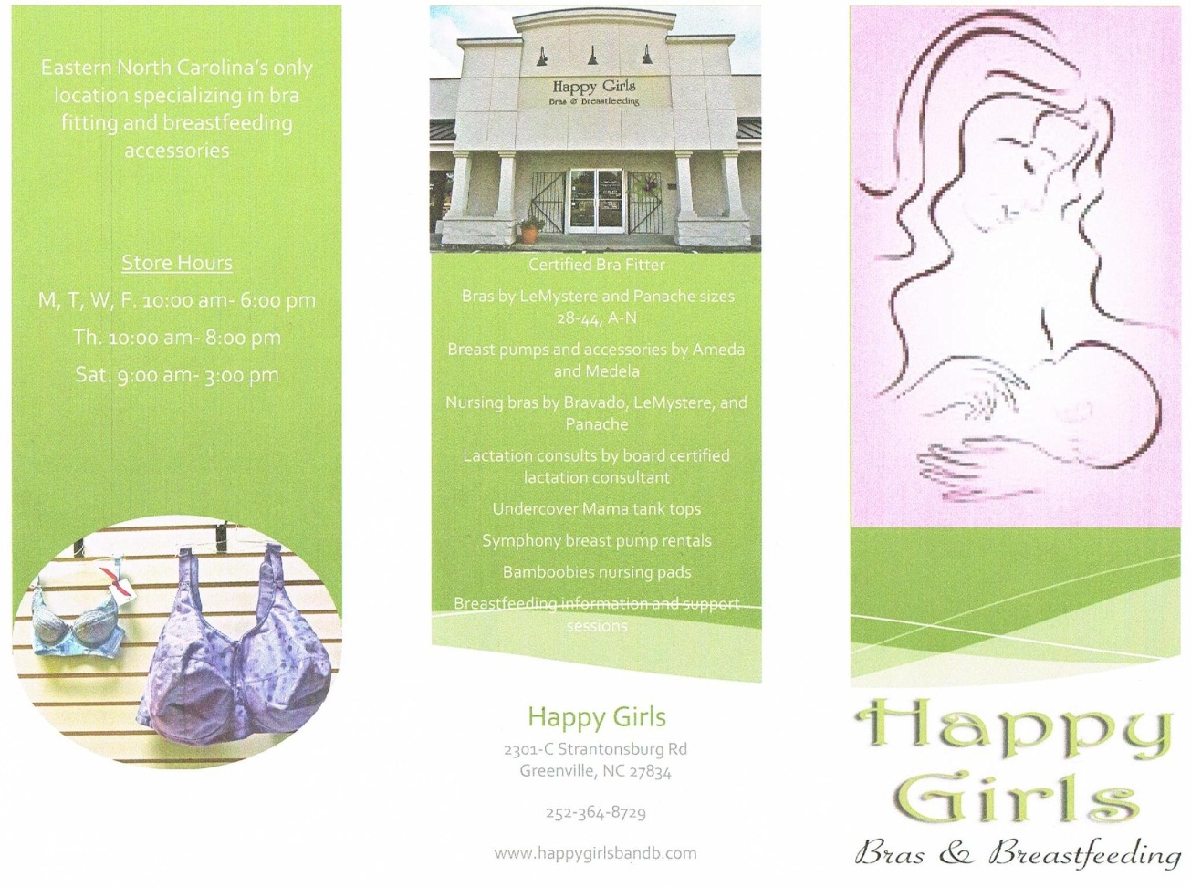
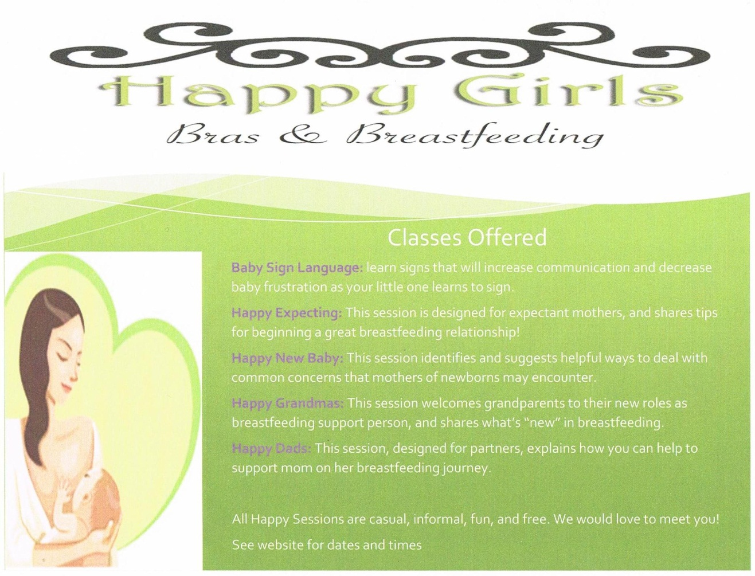

APPENDIX I: PICTURES

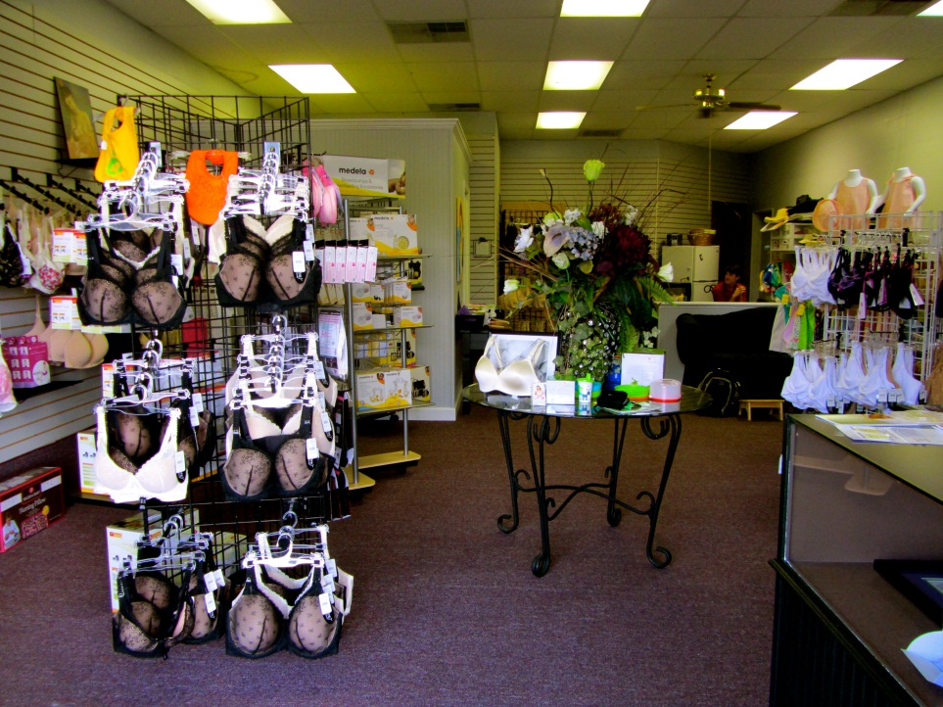
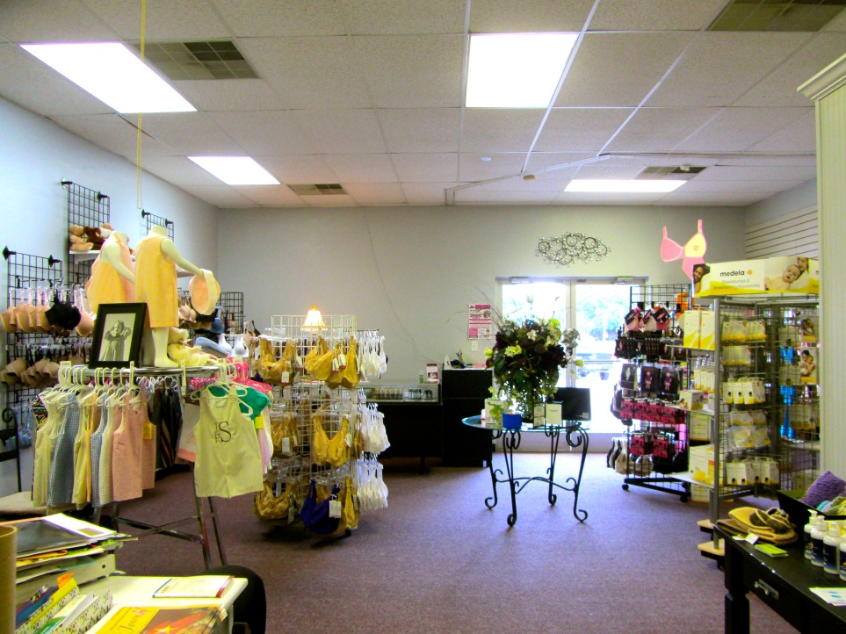
1 store view from front door
2 store view from back wall

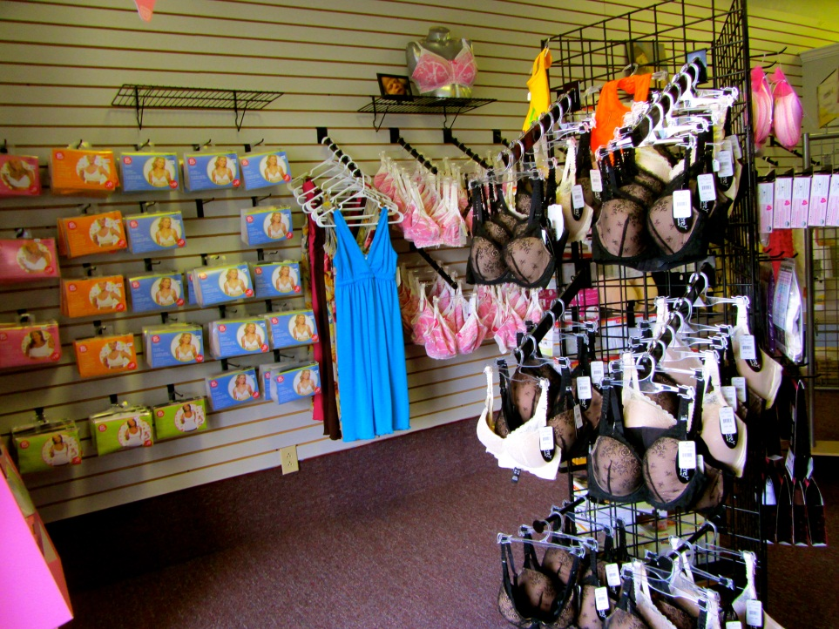
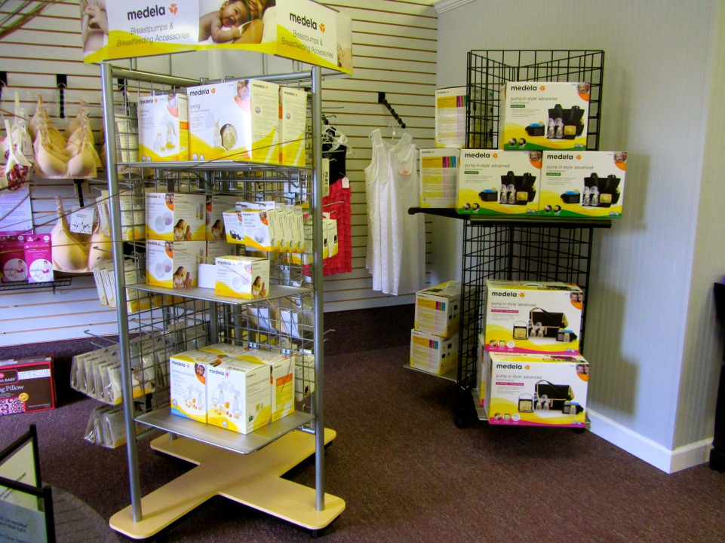
3 breastfeeding bra wall (left side of store)
4 breastfeeding equipment (left side of store)

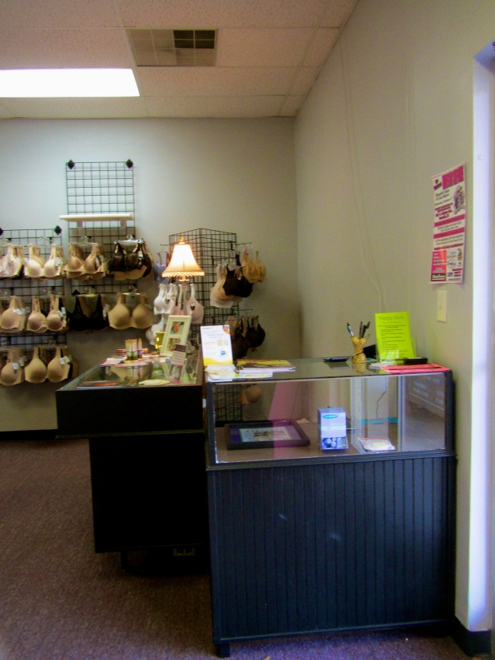
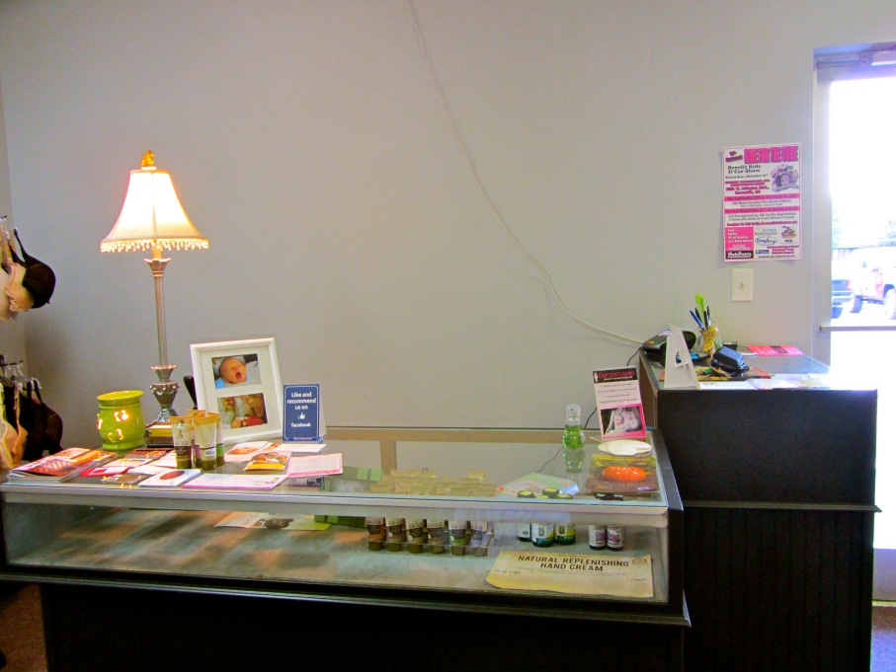
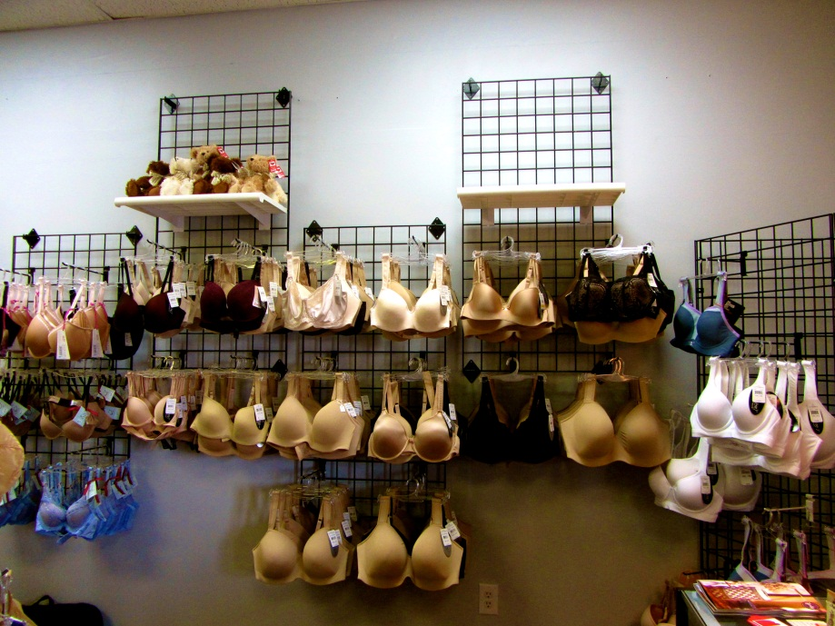
6 front counter
5 front counter (right of front door)
8 right side of store
7 regular bra wall
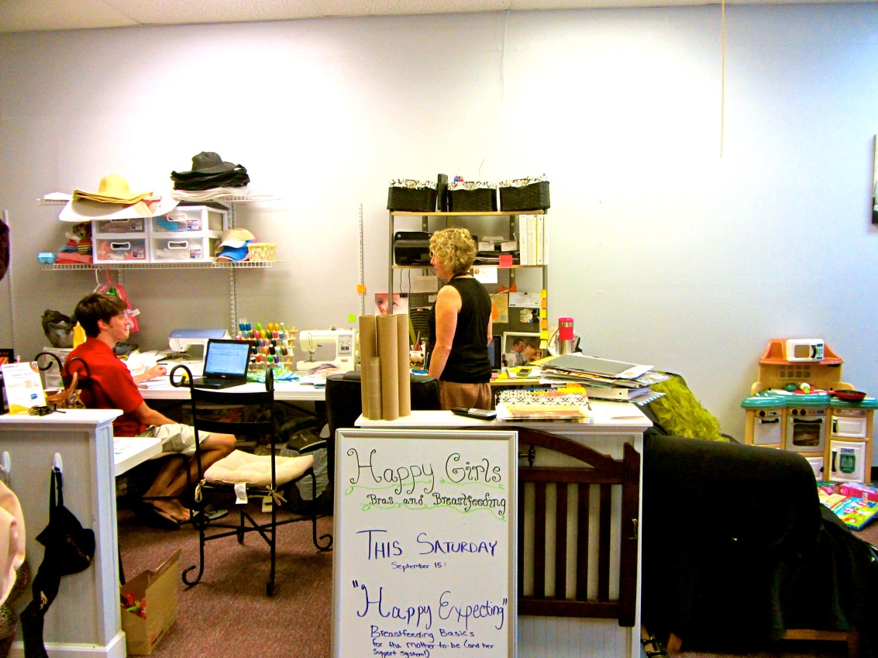
9 office space
10 office space
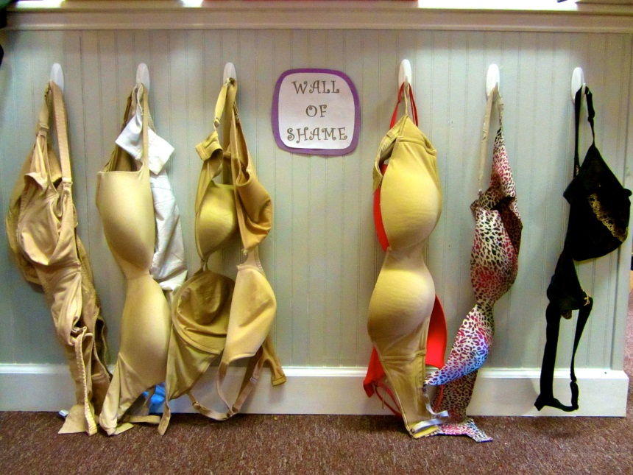
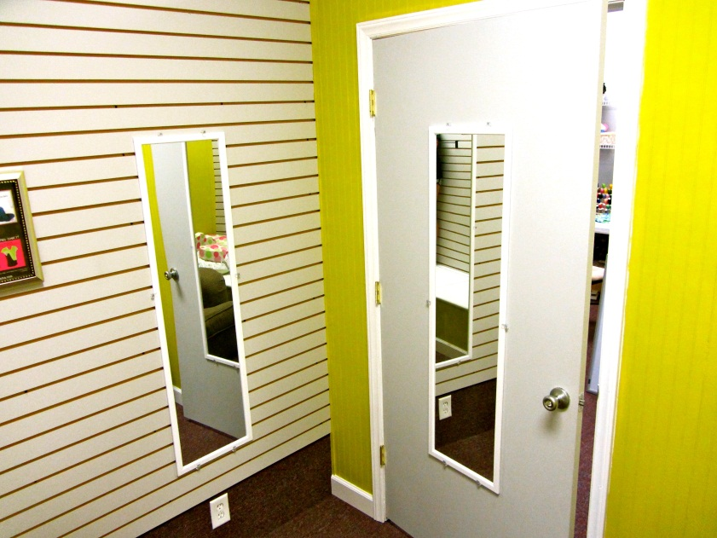
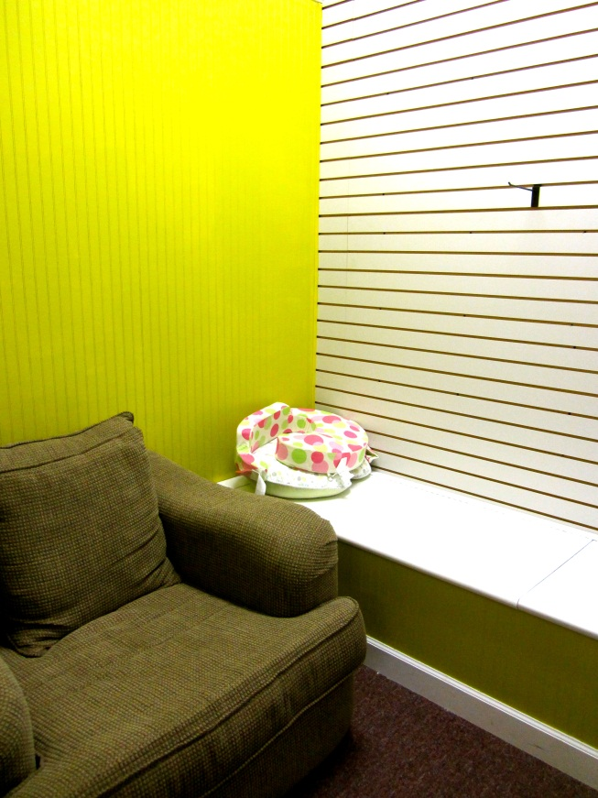
13 bra wall of shame
14 outside dressing room at back of store
12 dressing room
11 dressing room
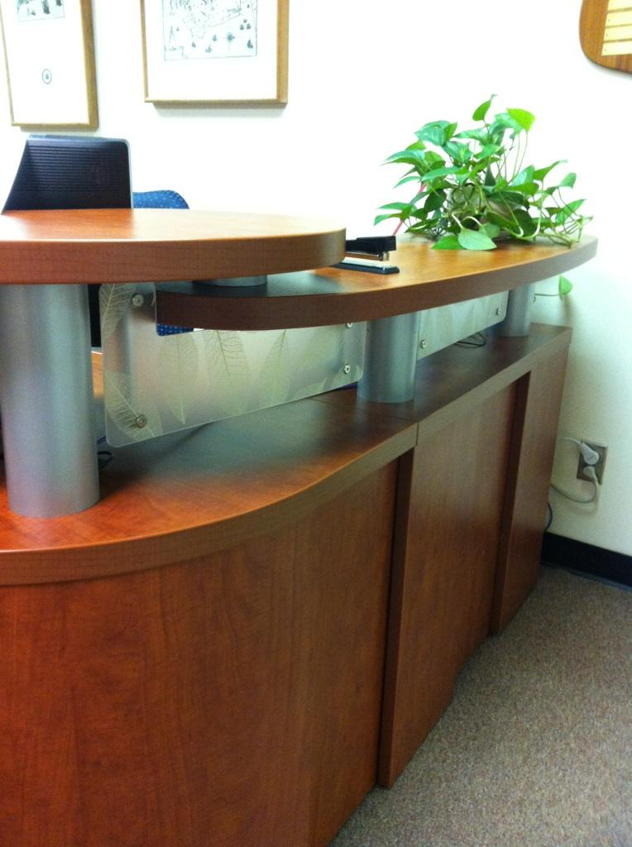
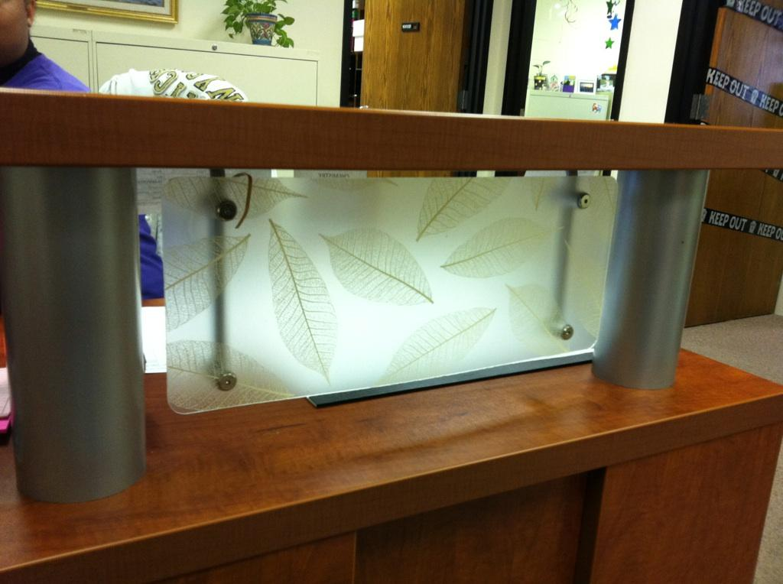
example office wall/barrier
CLIENT ACKNOWLEDGMENT

I, Sophie Szymeczek, hereby acknowledge receipt of the consulting report presented by the SBI student team. I also submit that the report has been explained to me, and I understand and accept the contents therein. Further, I acknowledge the East Carolina University Small Business Institute shall maintain a copy of said report.

______________________________________
Name: Sophie Szymeczek
Date: December 6, 2012

